**Department of Computer Engineering TE Computer-A (2020-21 Sem I) Computer Networks Practical Assignment B3 [Max Marks: 10]**

**Submitted by : Himanshu Shekhar Padhi (3325)**

* **RIP(Routing Information Protocol) PROTOCOL**

Network Topology (RIP)

1. Drag and drop PC from End Devices.
2. Drag and drop switch(2950-24) for each network and router(1841) for each network.
3. Connect the PC and switch using Copper straight through cable in fast ethernet ports of both PC and switch.
4. Repeat Step 3 to connect switch to router.

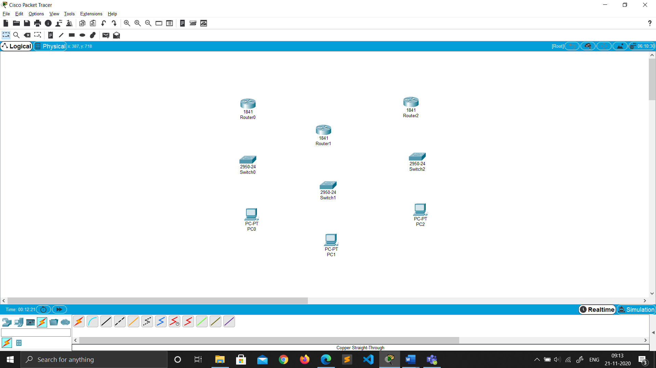

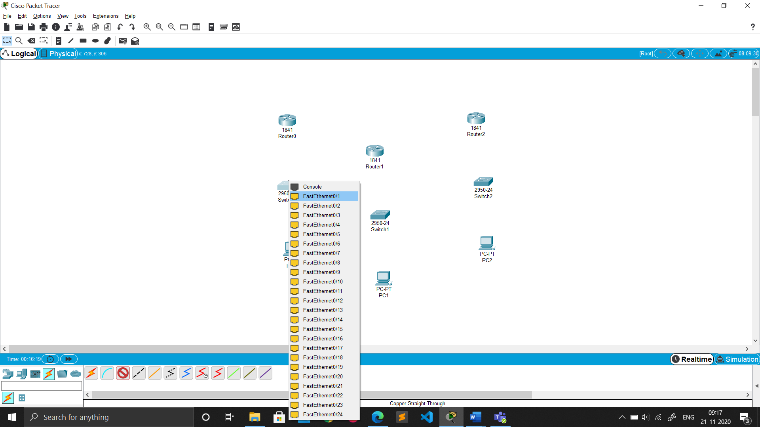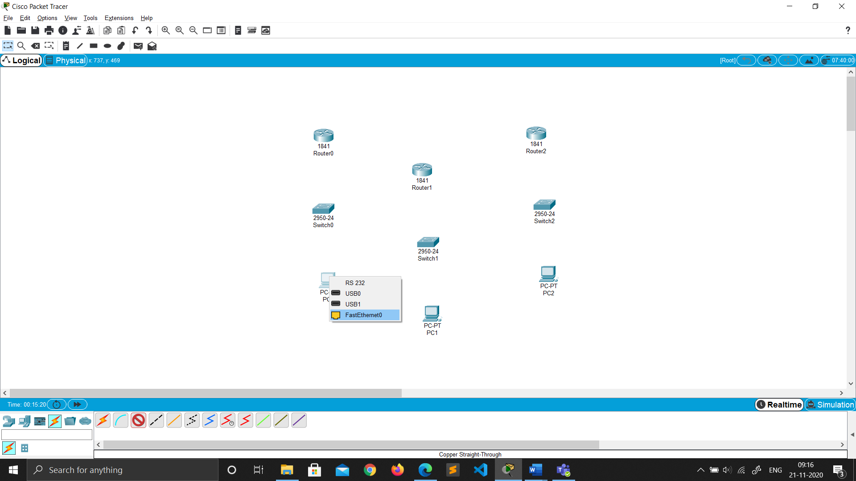

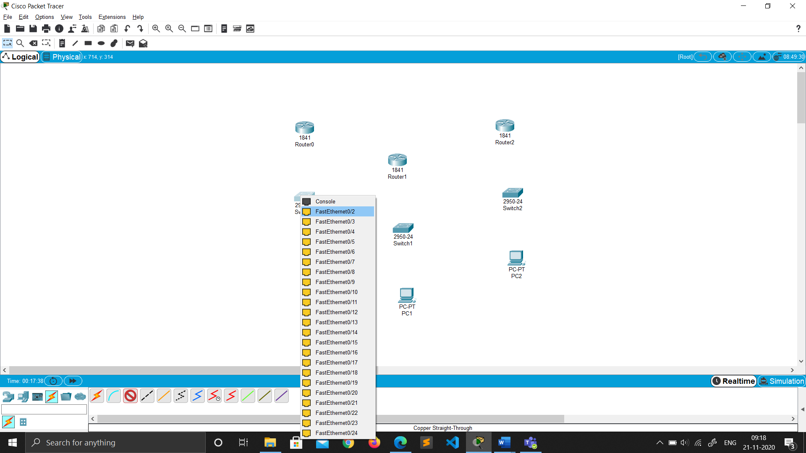

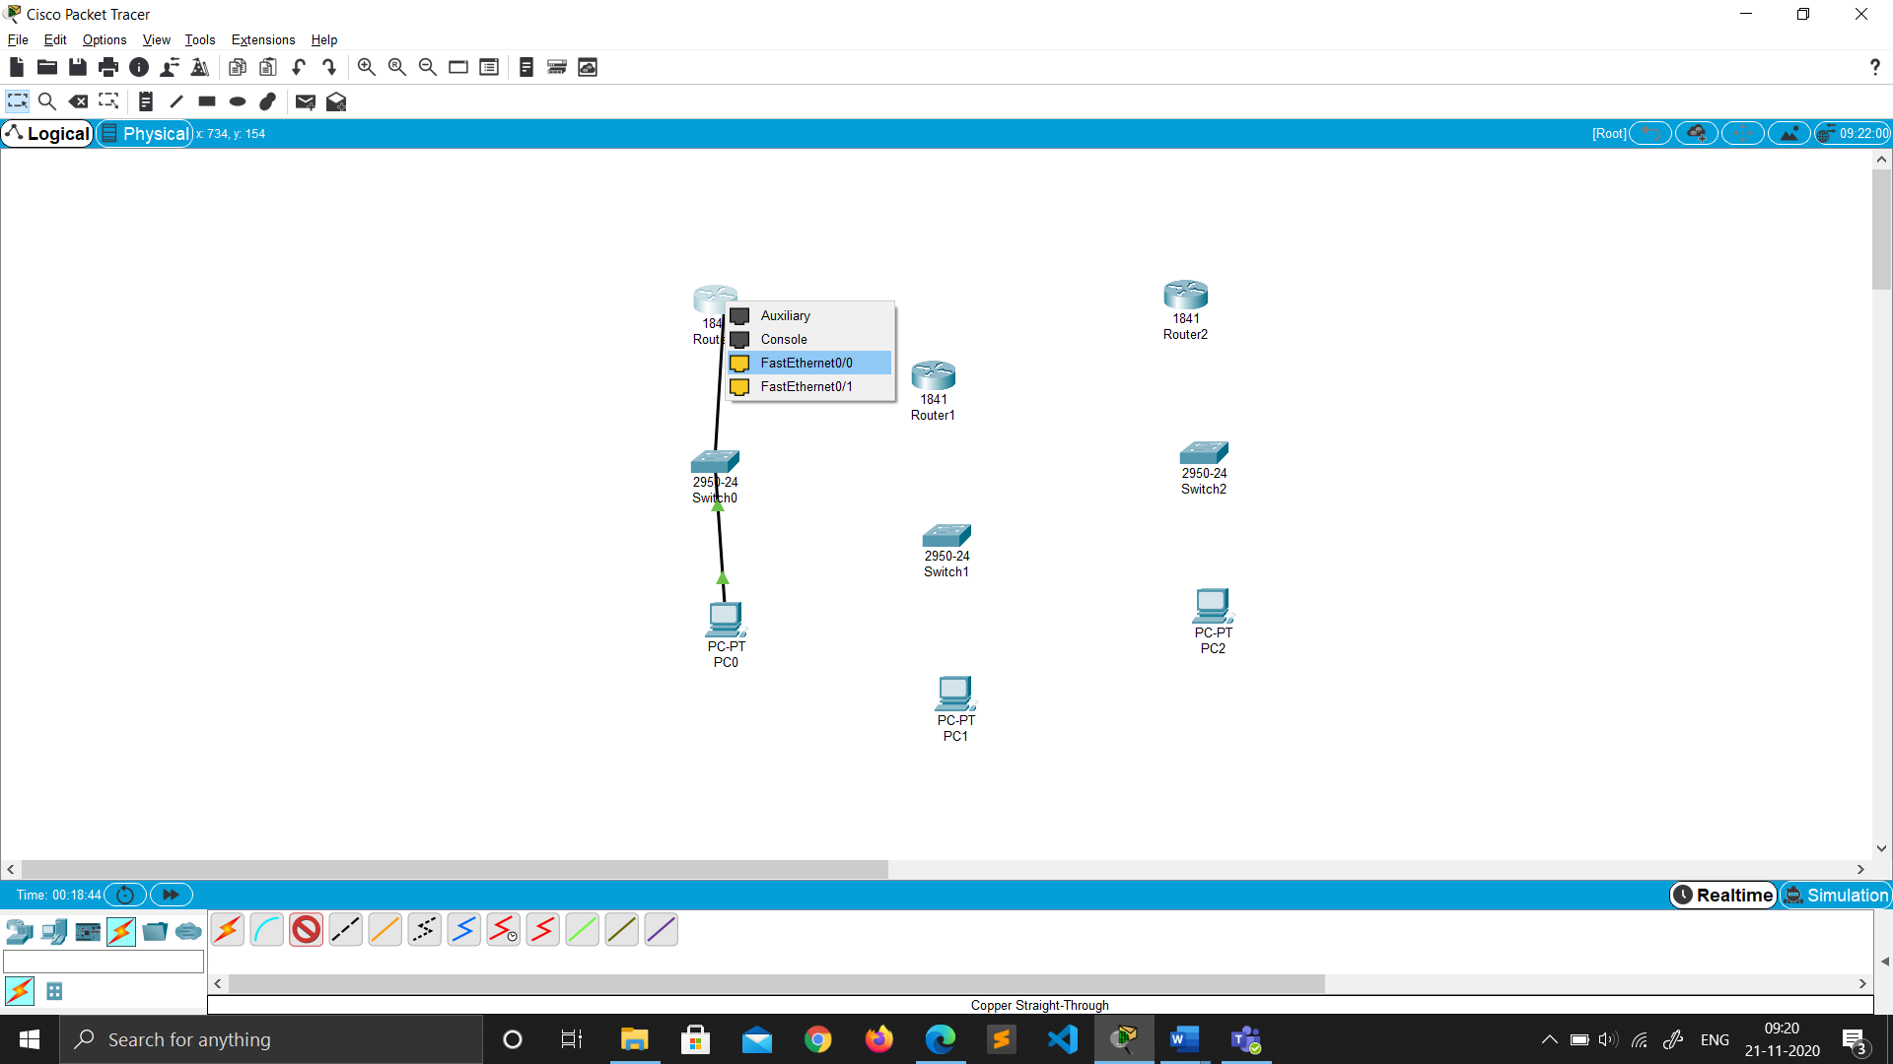

1. As by default not many ports are available on routers, we need to add some extra serial ports to form the network.
2. To add the serial ports click on the router go to PHYSICAL ----> WIC-2T.
3. Turn off the router by toggling(click) the switch.(FOR ALL ROUTERS)

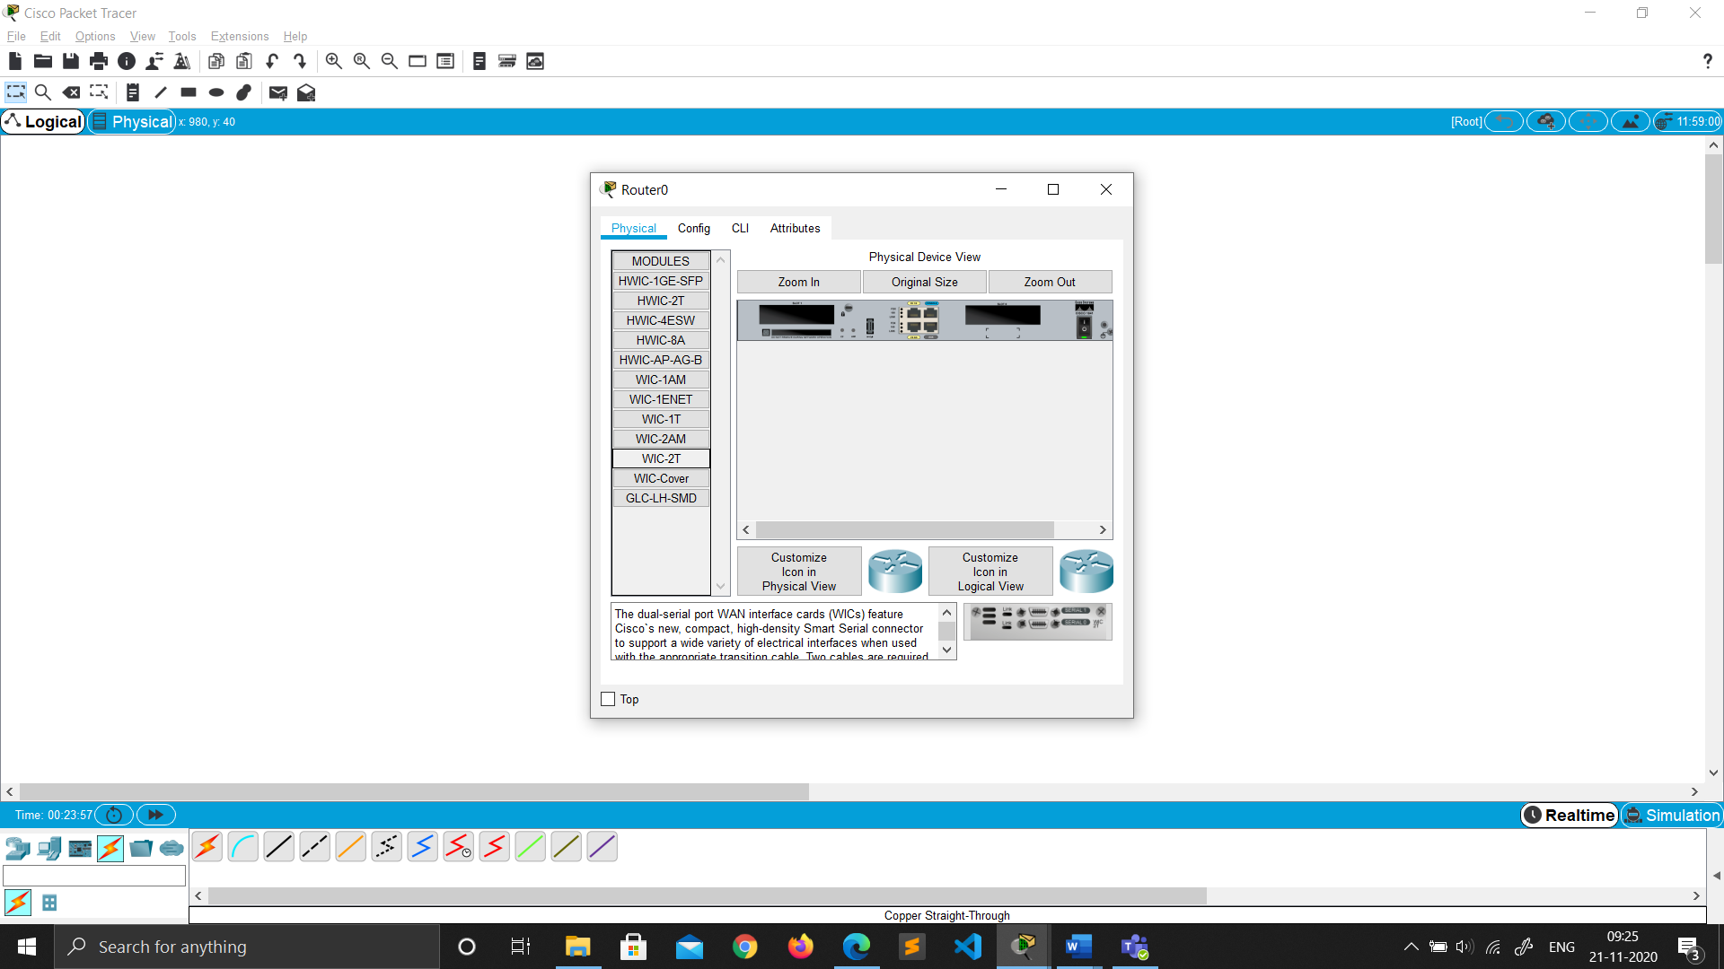

1. Now Drag and drop the ports image from bottom just to the left of switch.

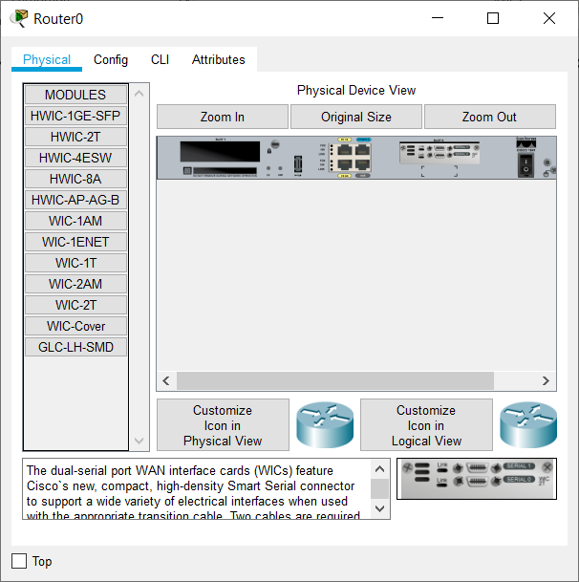

1. Now toggle(click) the switch to turn on the router.
2. Now to connect the routers select the **serial DTE cable** and connect the routers using the serial ports.

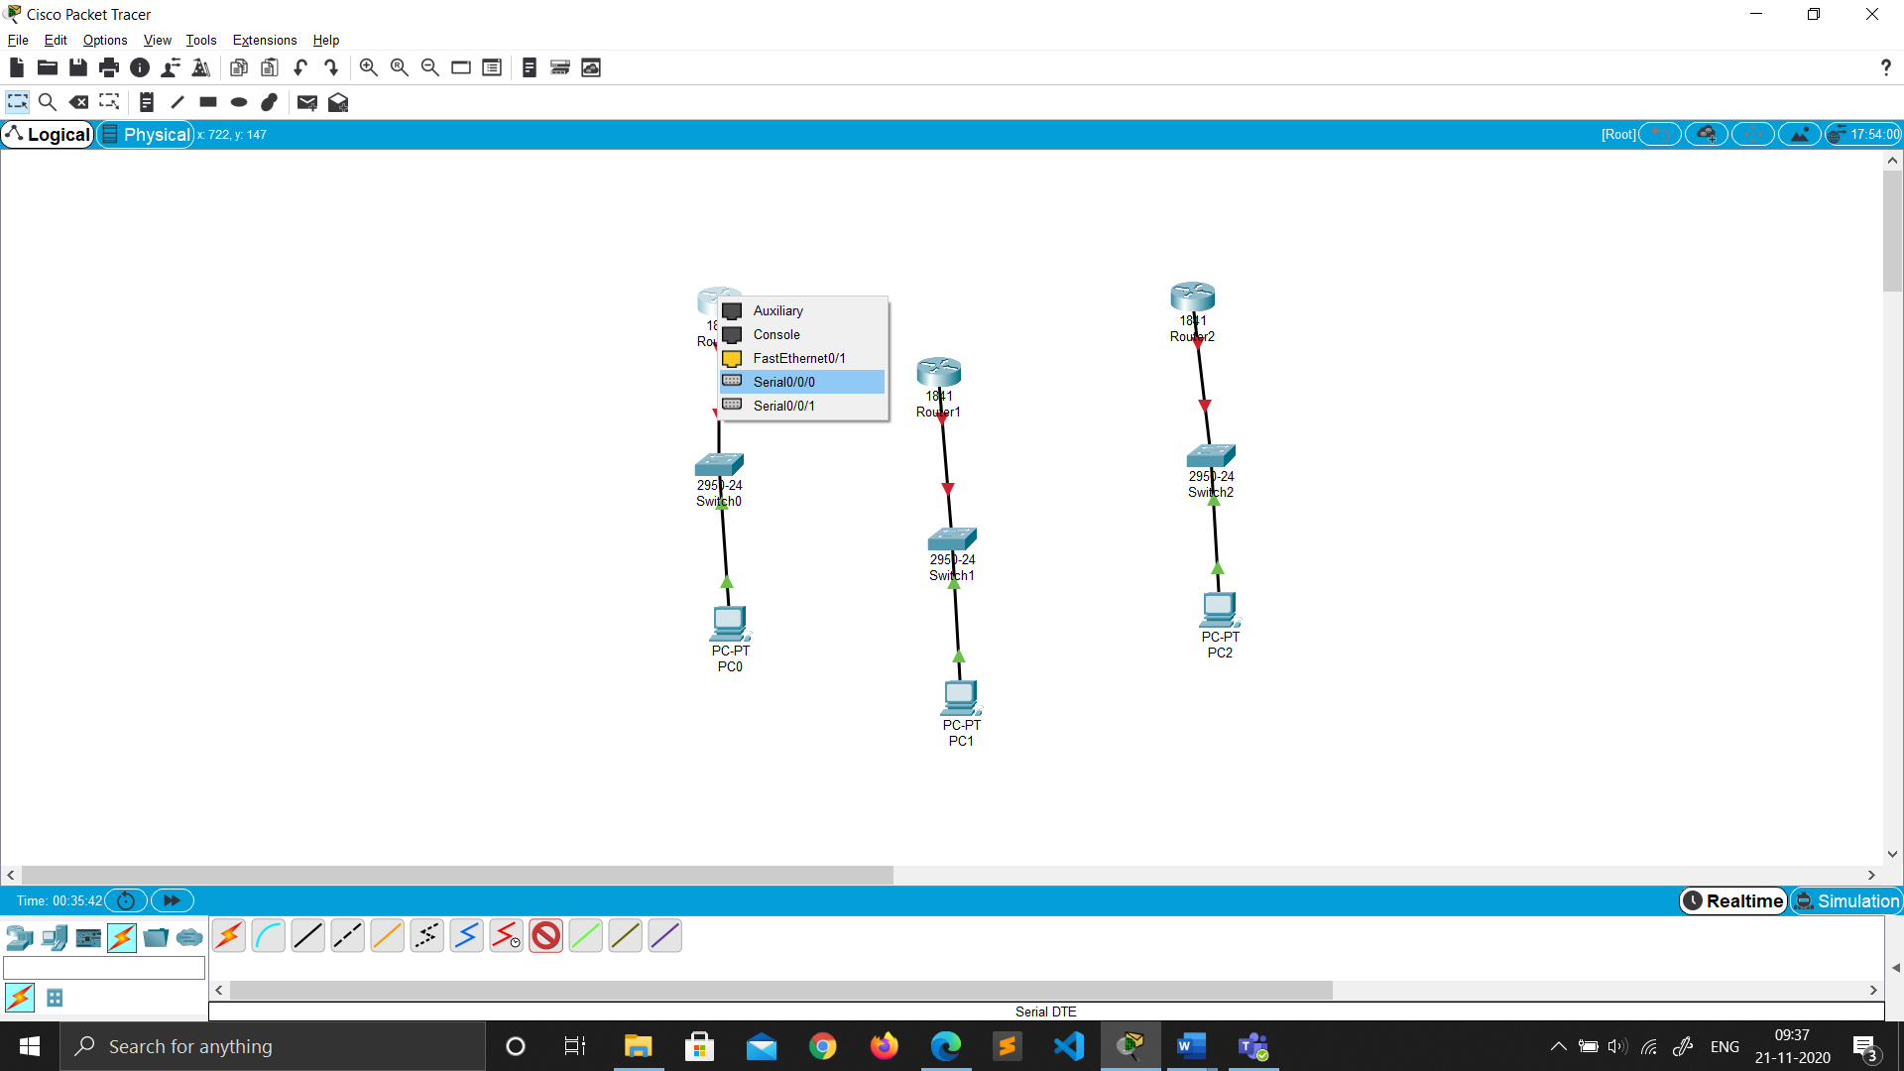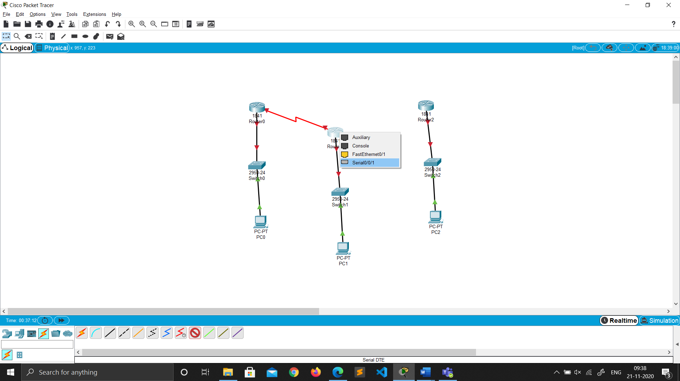

**Router 0 Router 1**



**Router 1 Router 2**

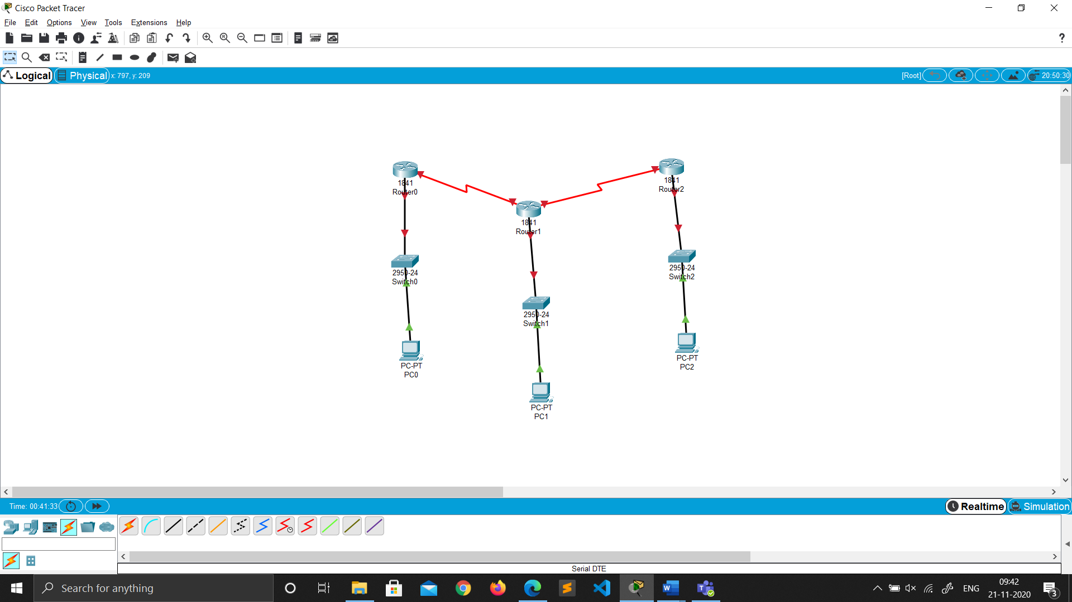

**NETWORK**

Ip Address Configuration (RIP)

ADDING gateway in router

1. Click on the router.

2. Go to Config ->Fast ethernet 0/0.

3. Then add the gateway for each network in all the routers.

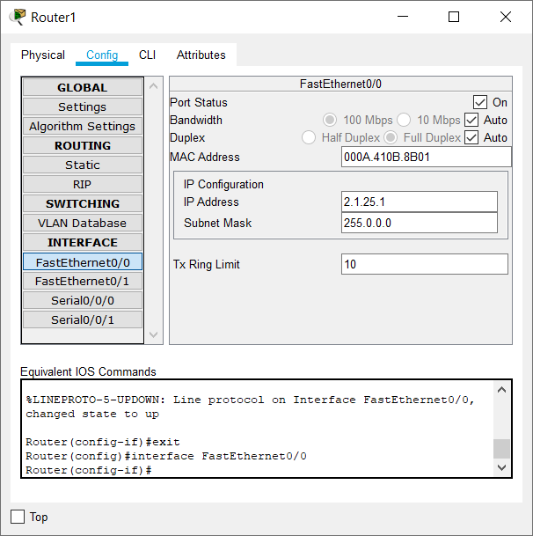4. Then turn on the port.

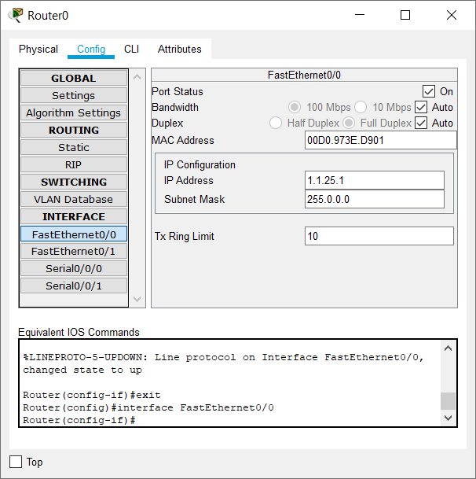

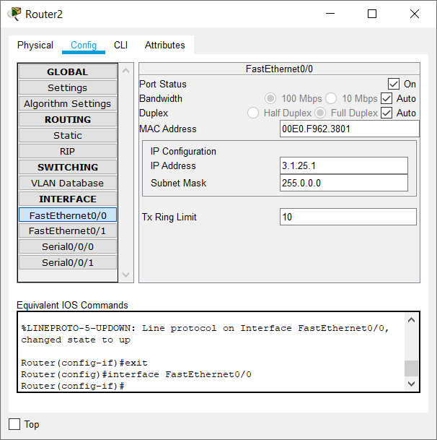

Assigning IP address to the PC’s

1. Click on the PC.

2. Go to Desktop ->IP configuration.

3. Add the Ip address and the gateway.

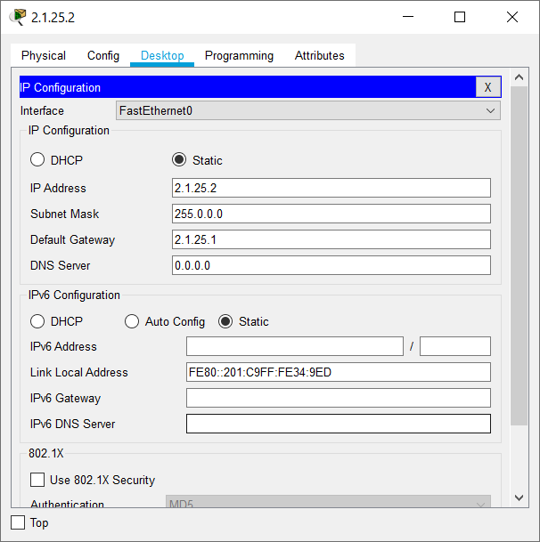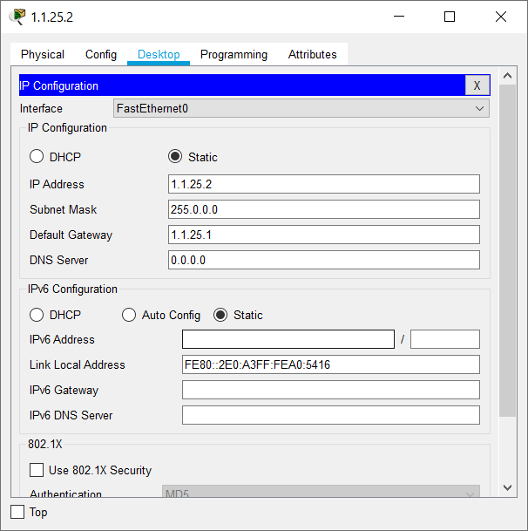

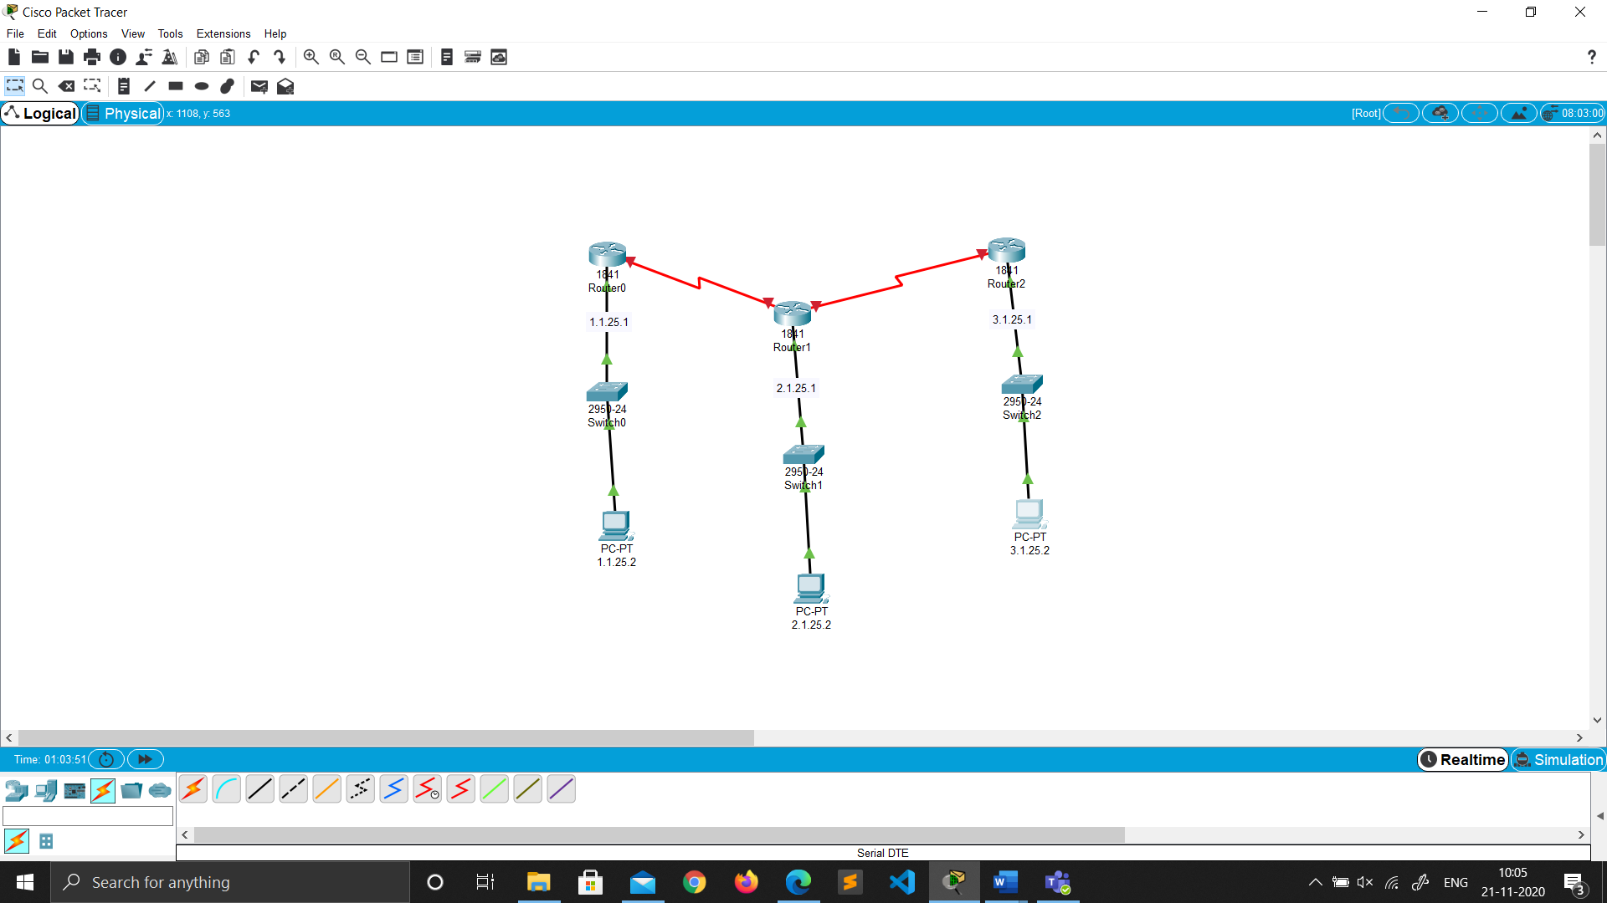

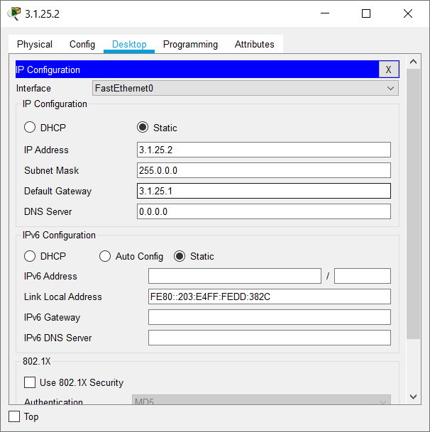

Connecting Router’s

1. Click on the router.

2. Go to Config.

3. Then config the serial ports as required.

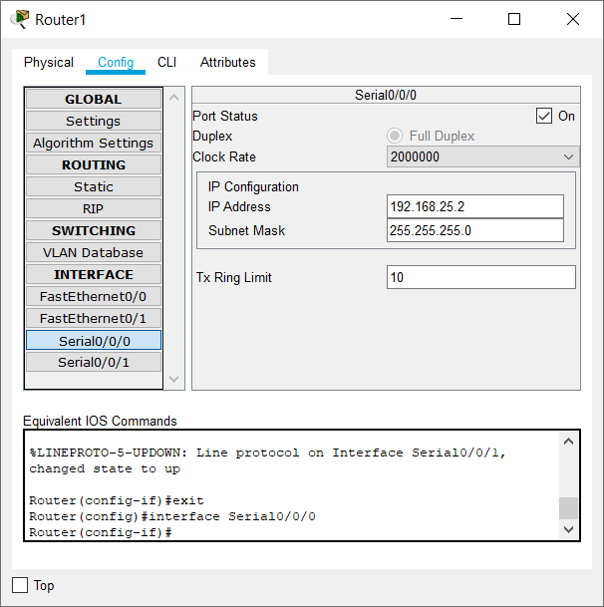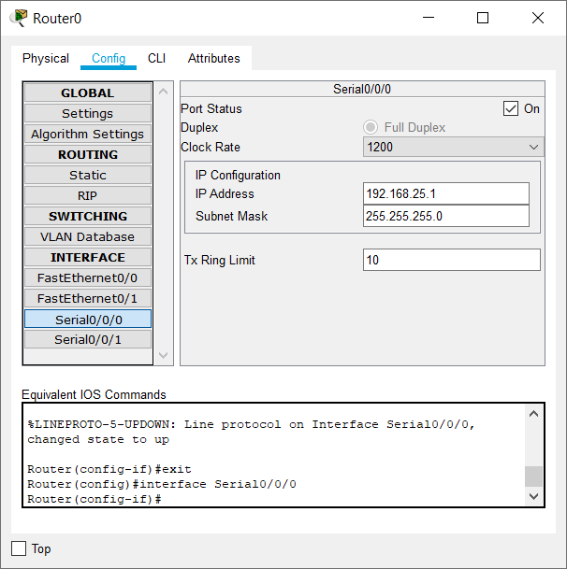

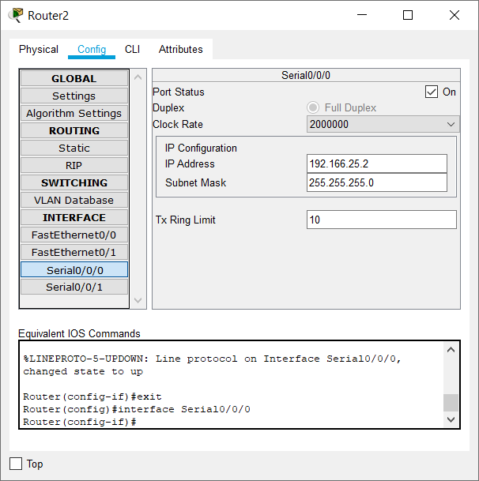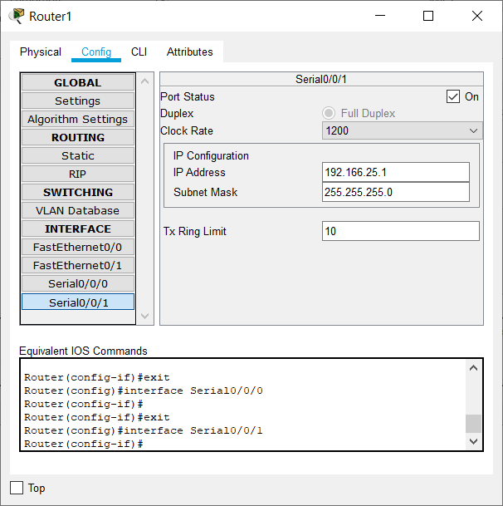

Configuring RIP

Adding networks to communicate between (for each router)

1. Click on the router.

2. Go to Config -> RIP.

3. Add the network Id’s for each network (192.168.25.0 , 192.166.25.0 , 1.0.0.0 , 2.0.0.0 , 3.0.0.0).

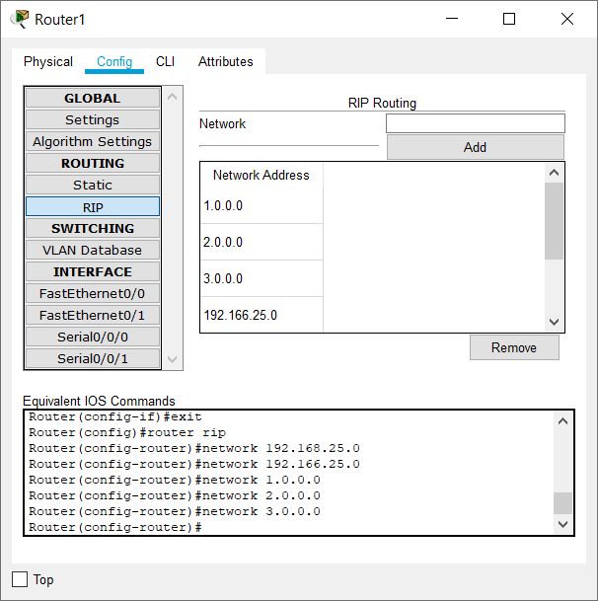4. Then click Add.

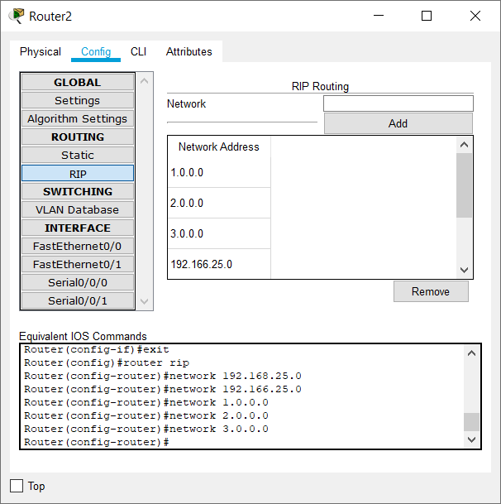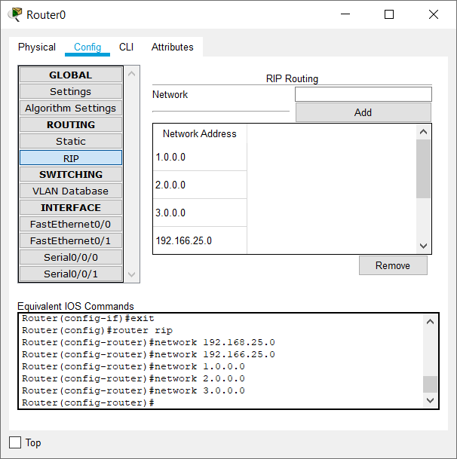

Real Mode Simulation (RIP)

Note : It may take 2 tries for the packet to reach successfully.

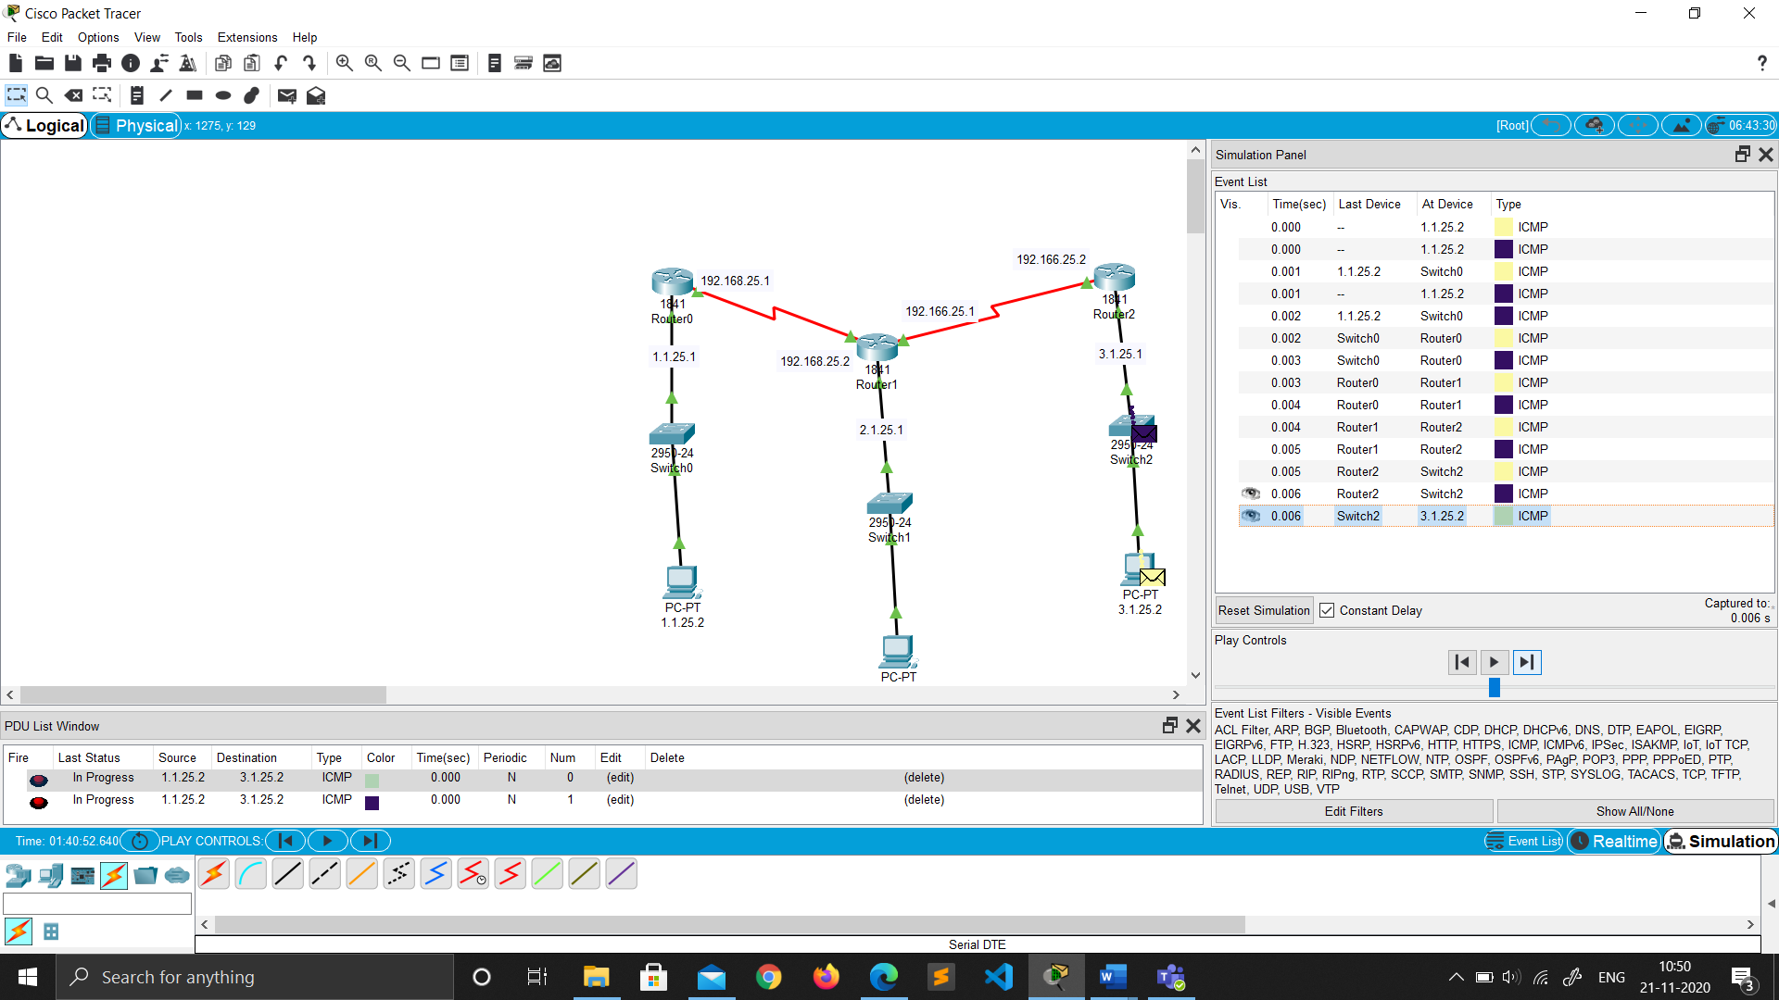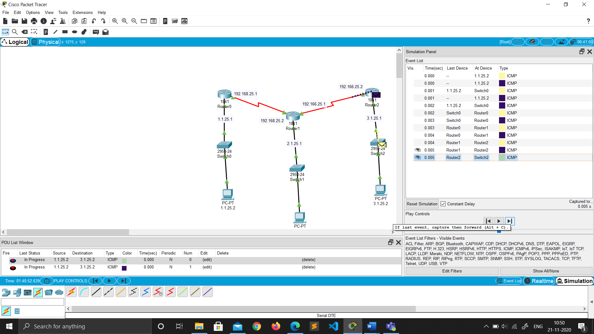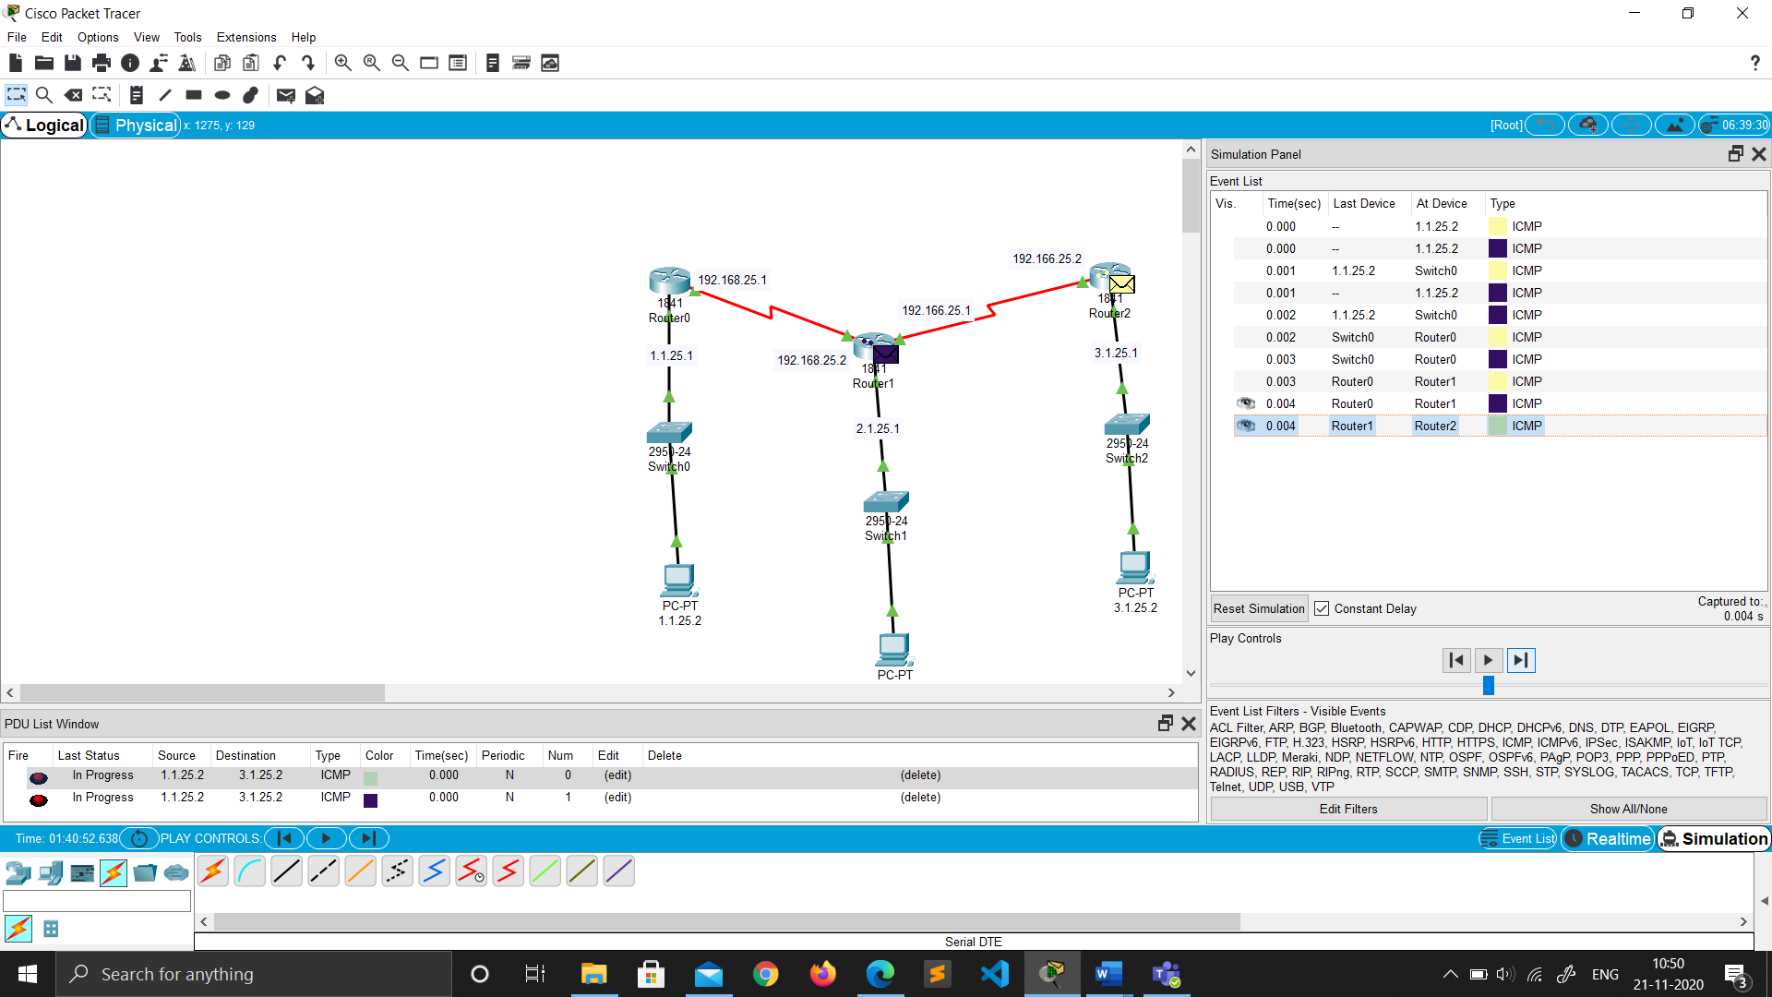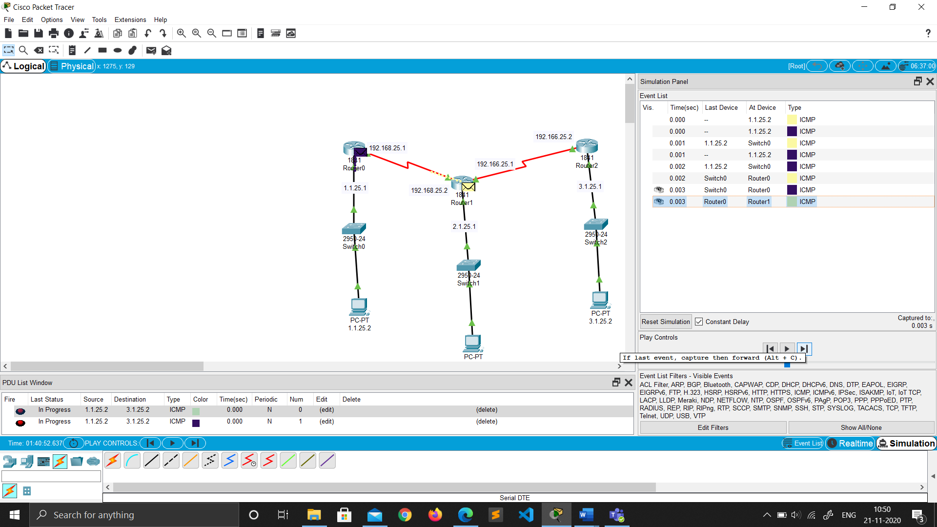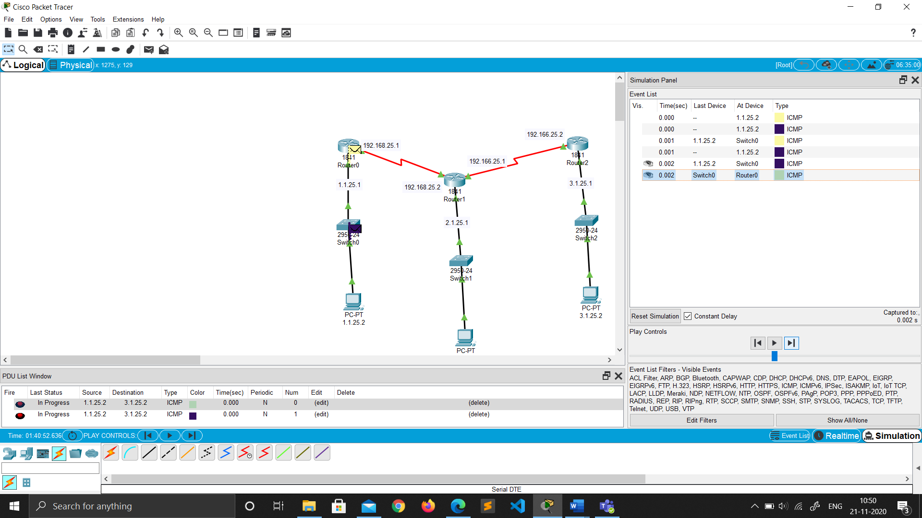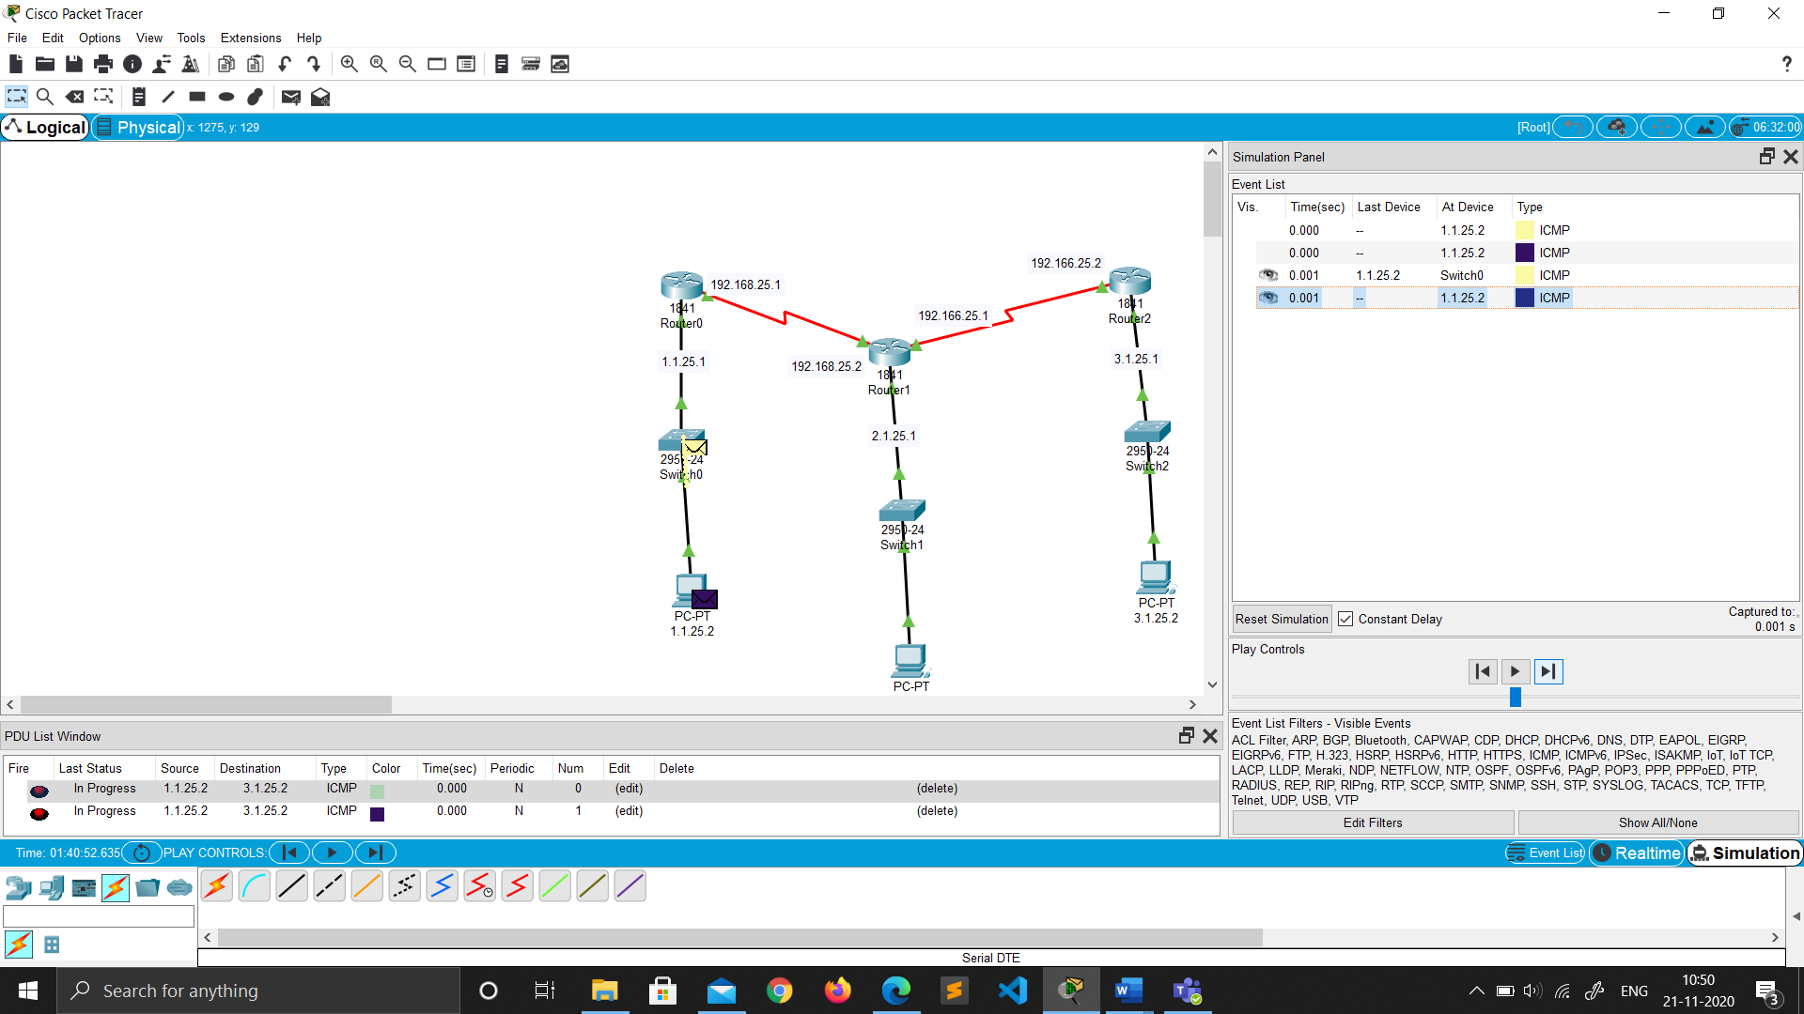

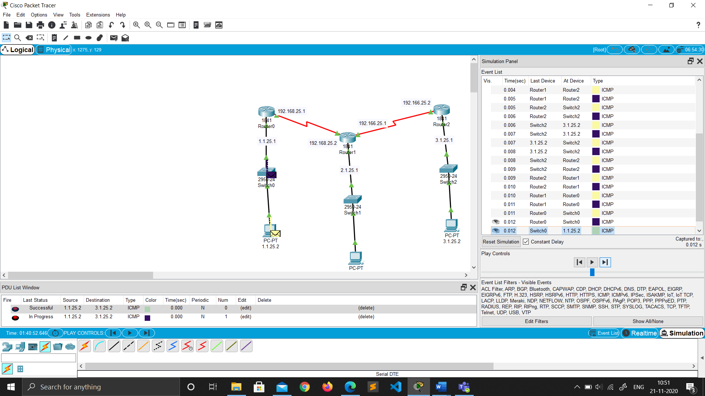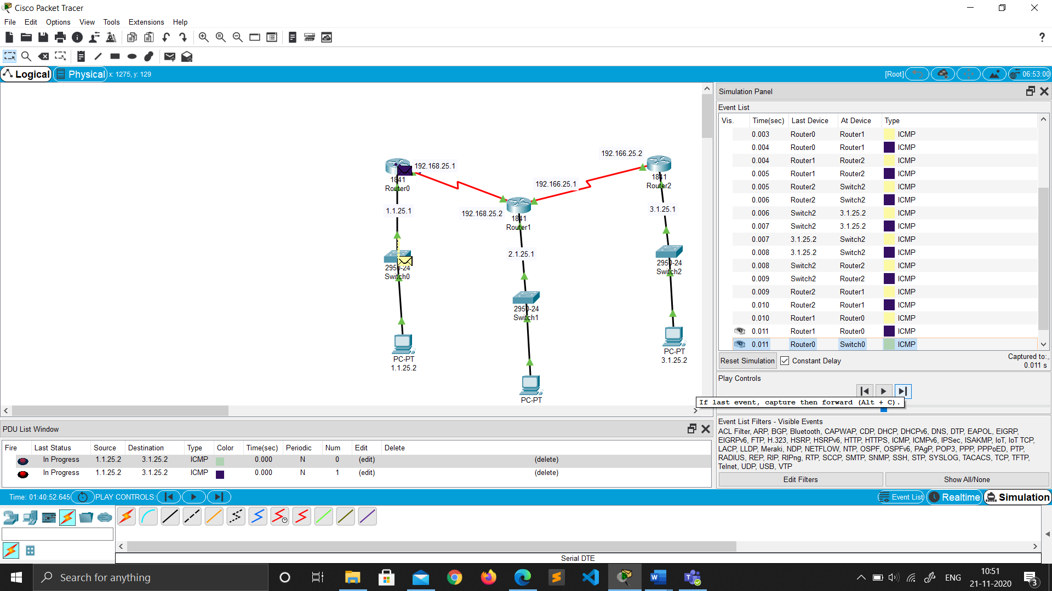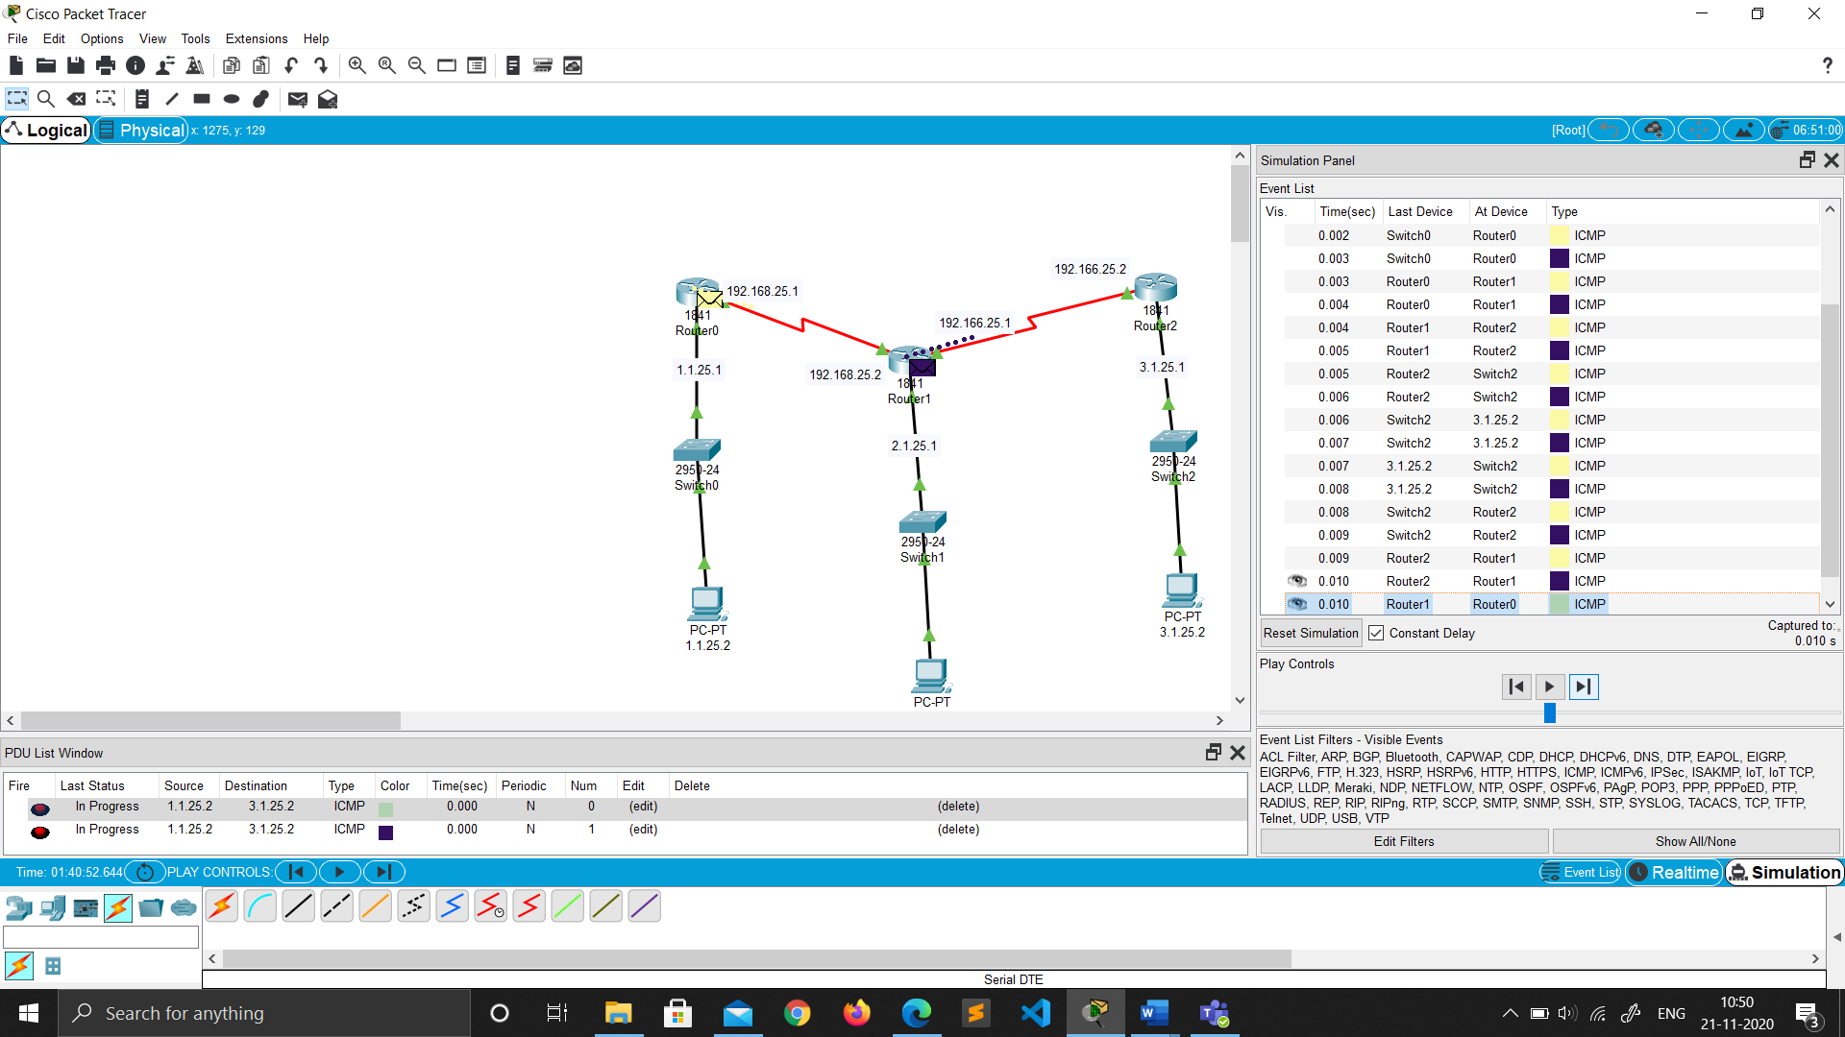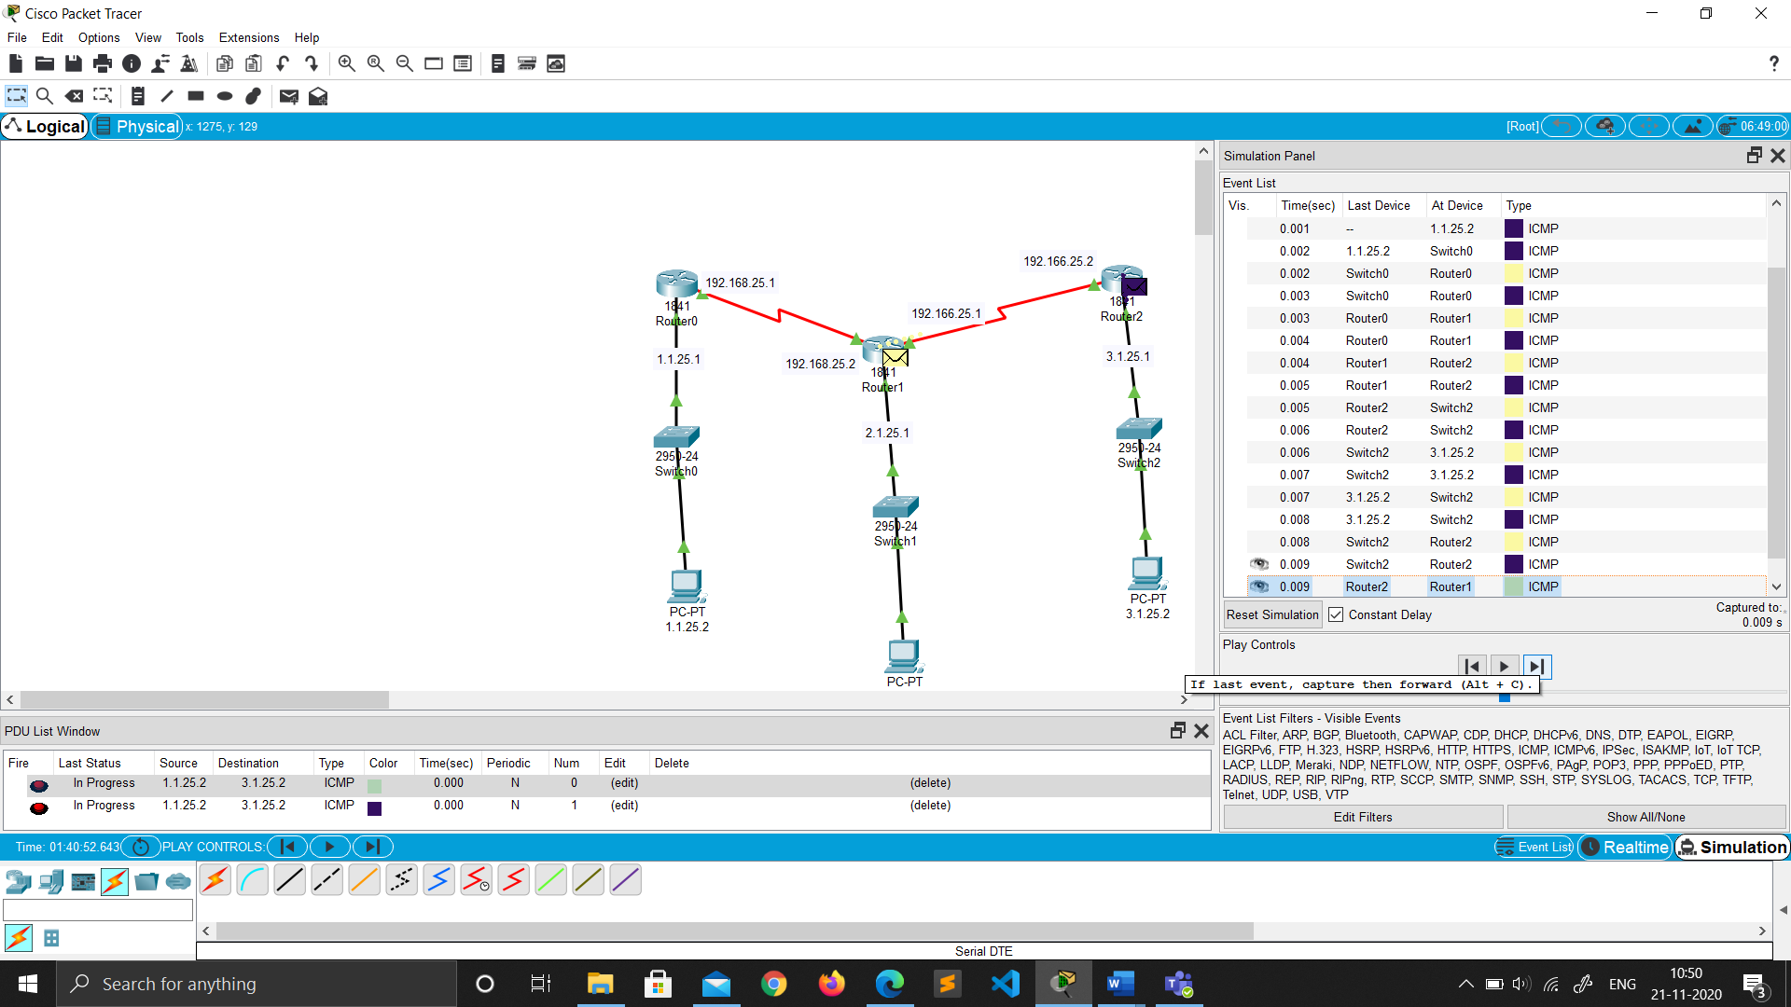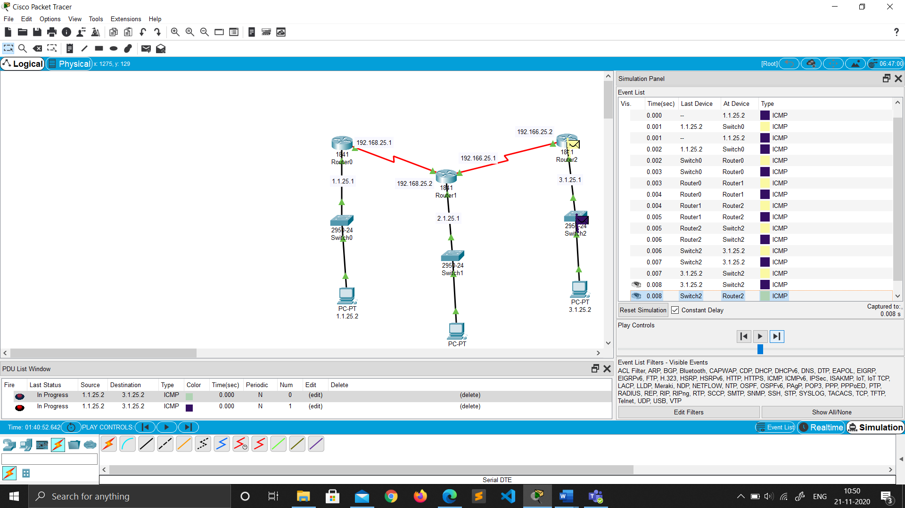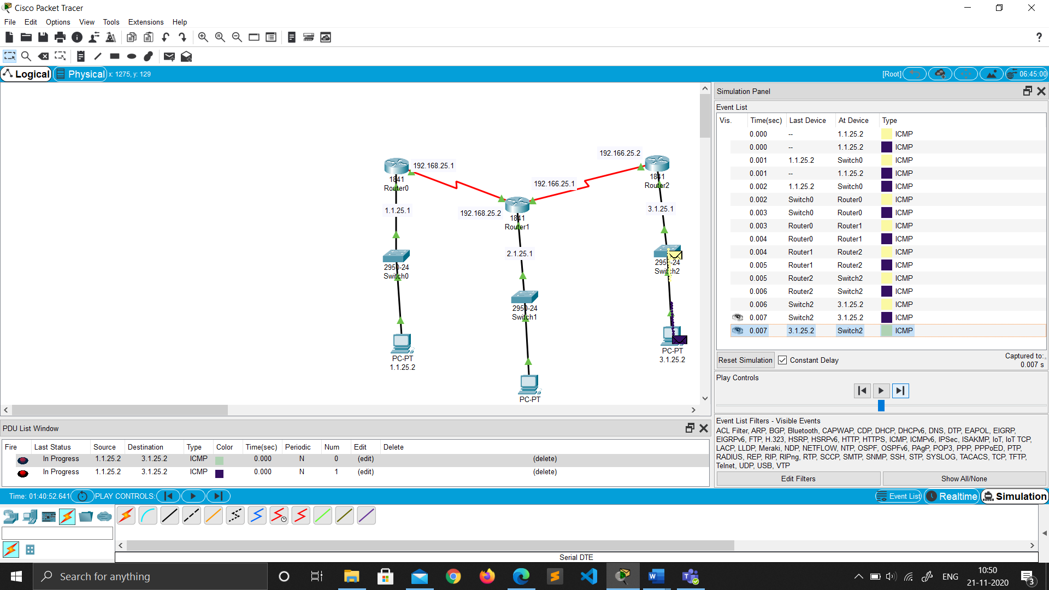

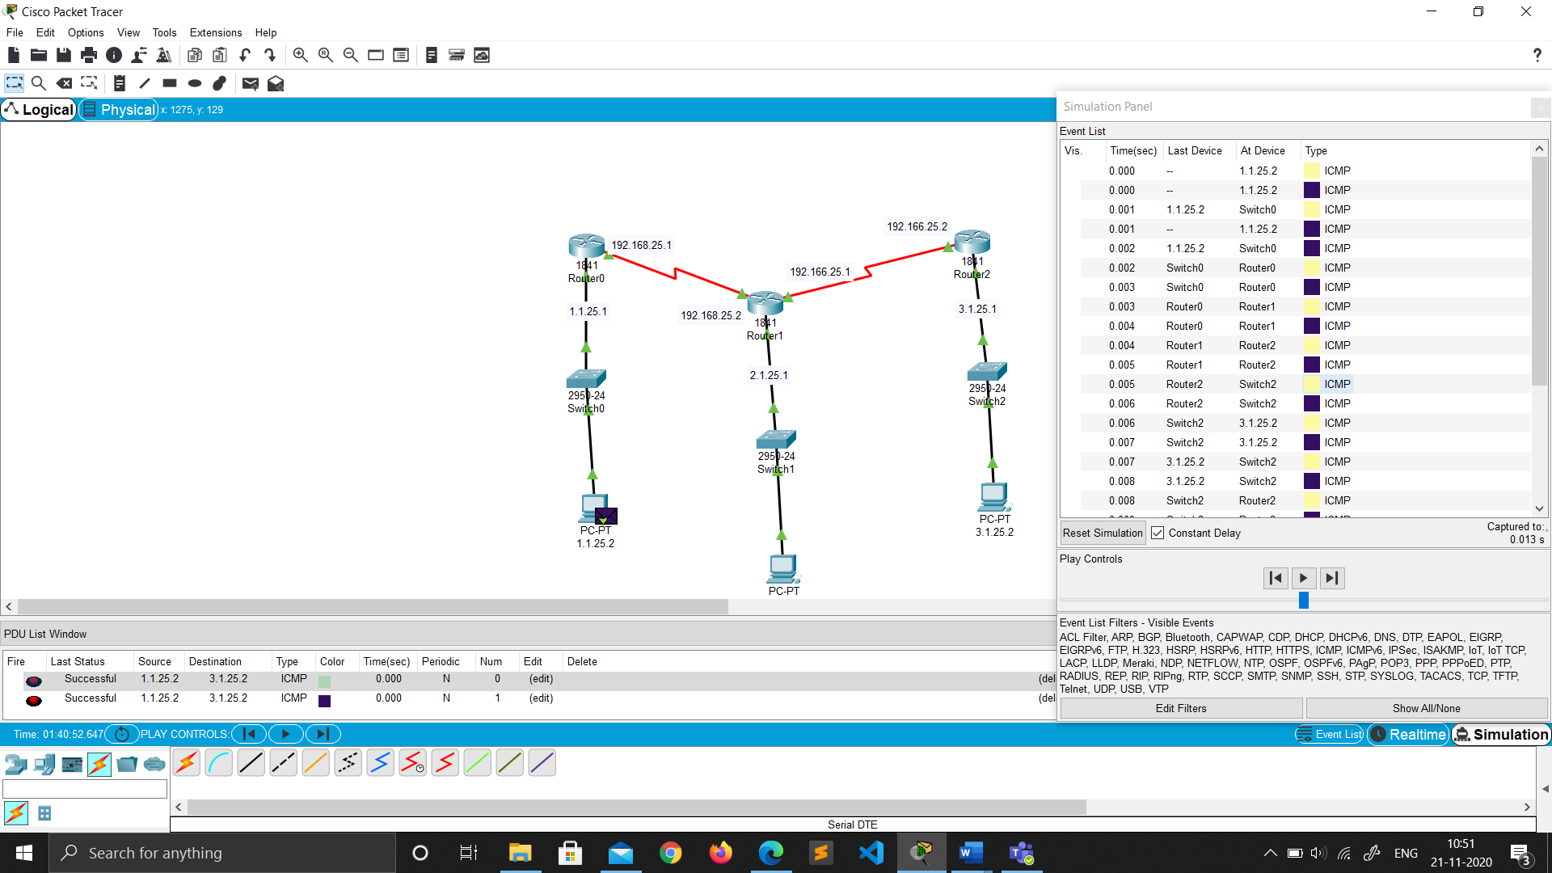

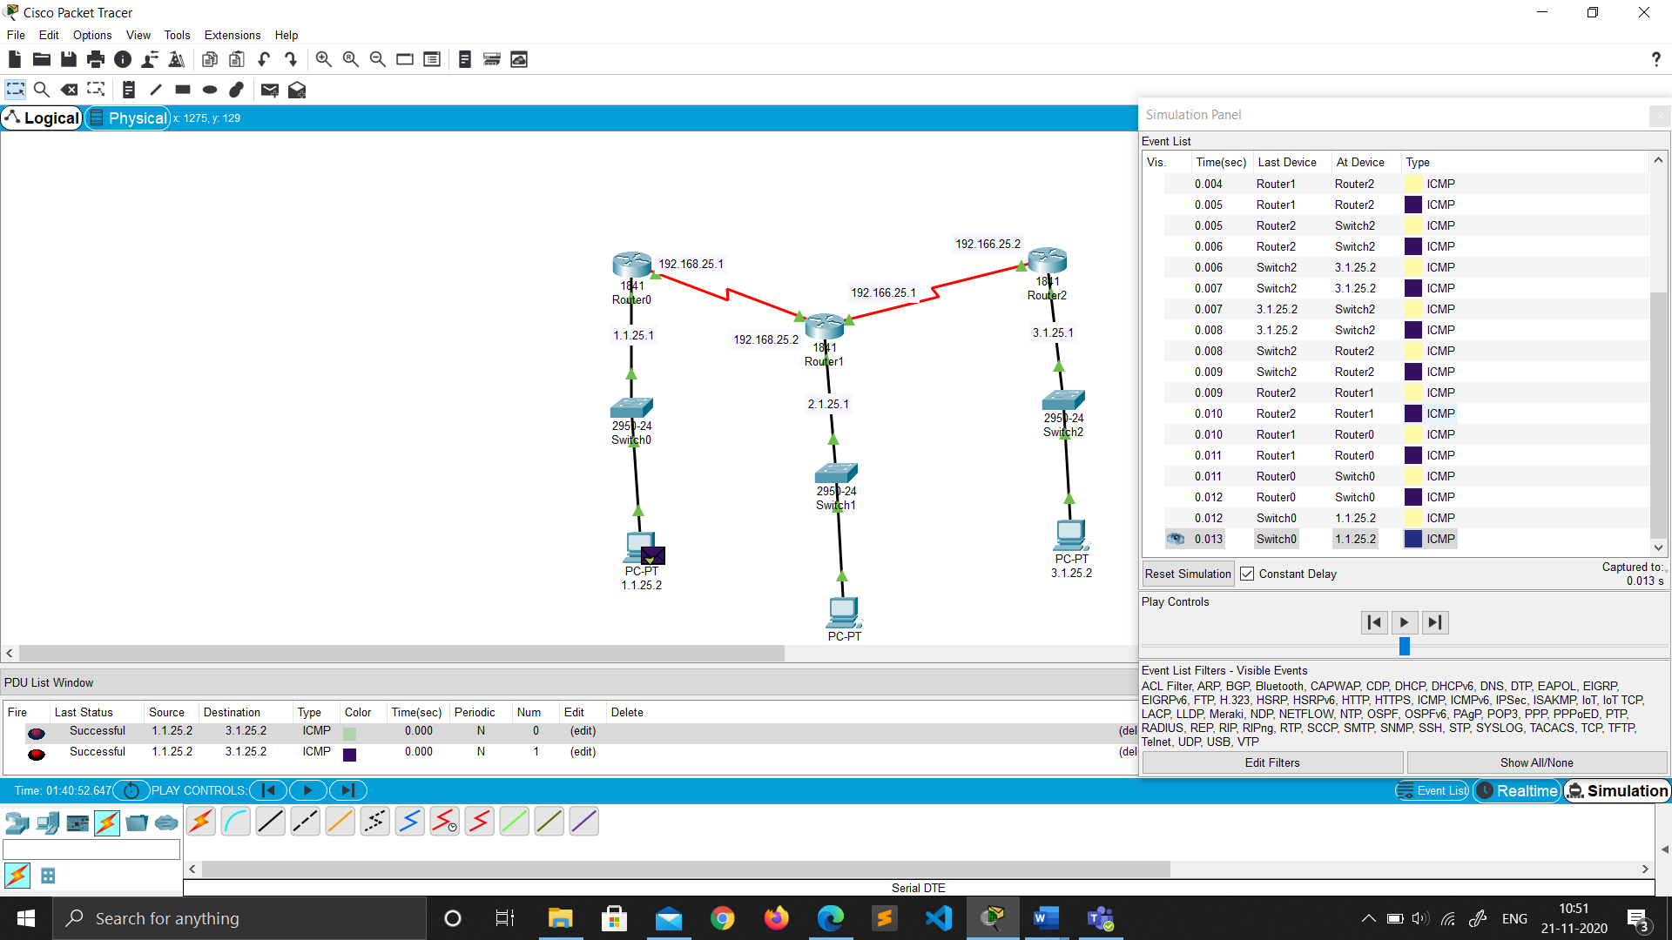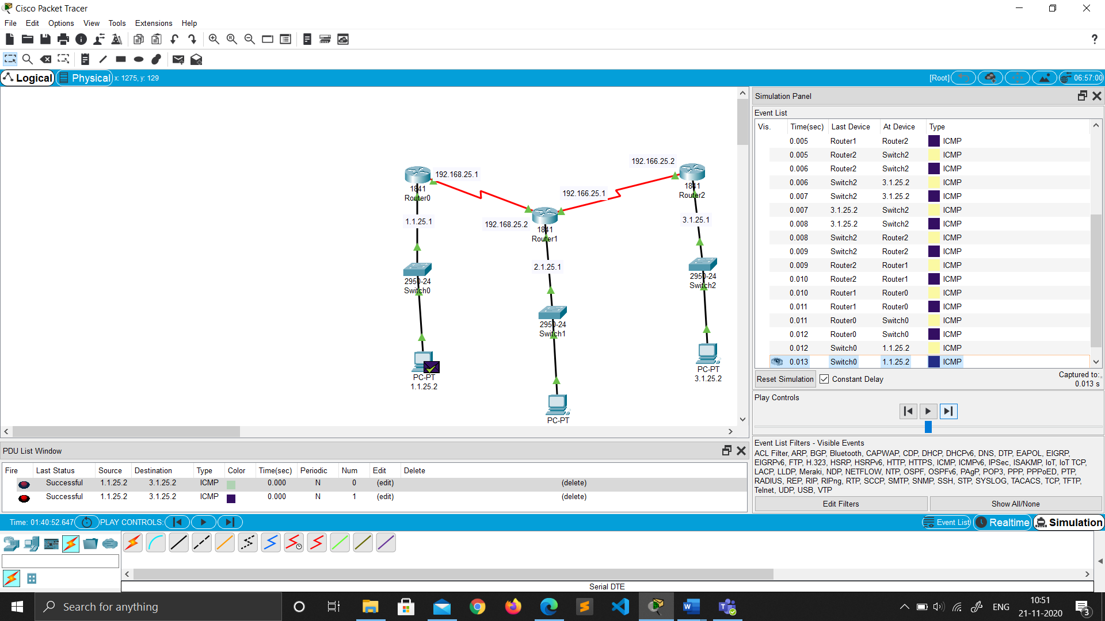

* **OSPF(Open Shortest Path first) PROTOCOL**

Network Topology (OSPF)

1. Drag and drop PC from End Devices.
2. Drag and drop switch(2950-24) for each network and router(1841) for each network.
3. Connect the PC and switch using Copper straight through cable in fast ethernet ports of both PC and switch.
4. Repeat Step 3 to connect switch to router.



1. As by default not many ports are available on routers, we need to add some extra serial ports to form the network.
2. To add the serial ports click on the router go to PHYSICAL ----> WIC-2T.
3. Turn off the router by toggling(click) the switch.(FOR ALL ROUTERS)



1. Now Drag and drop the ports image from bottom just to the left of switch.



1. Now toggle(click) the switch to turn on the router.
2. Now to connect the routers select the **serial DTE cable** and connect the routers using the serial ports.

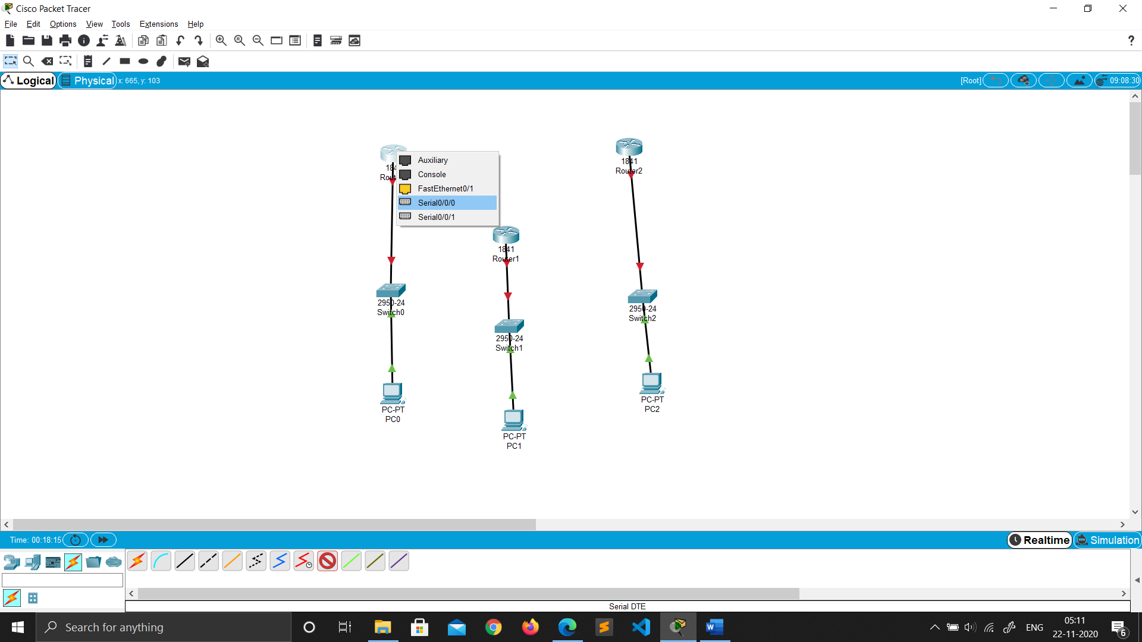

Router 0 Router 1



Router 1 Router 2



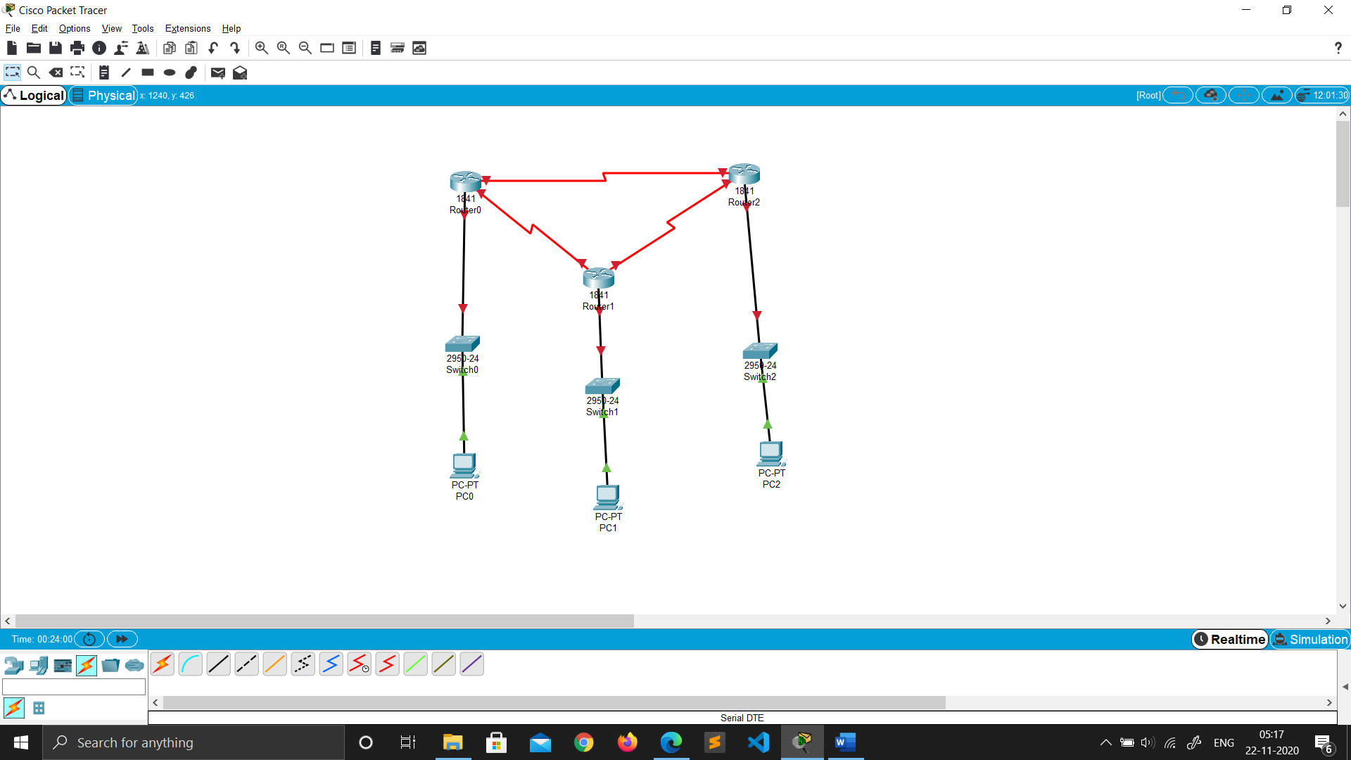 Router 0 Router 1

Network

Ip Address Configuration (OSPF)

ADDING gateway in router

1. Click on the router.

2. Go to Config ->Fast ethernet 0/0.

3. Then add the gateway for each network in all the routers.

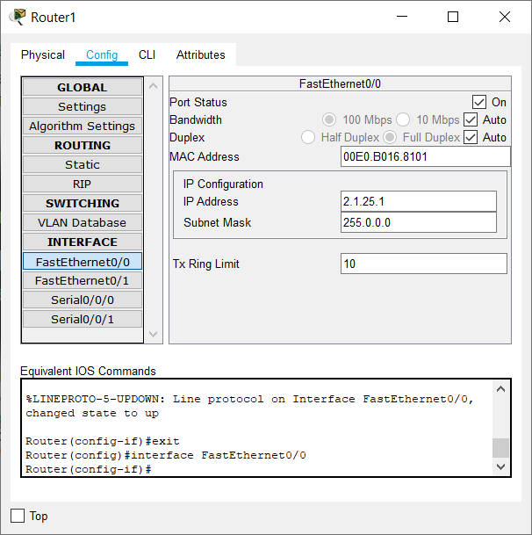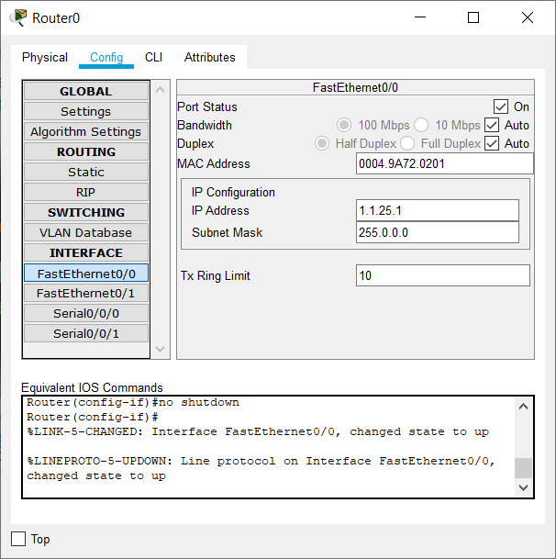4. Then turn on the port.

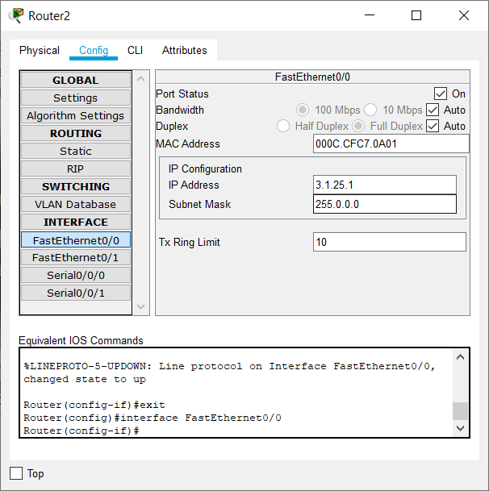

Assigning IP address to the PC’s

1. Click on the PC.

2. Go to Desktop ->IP configuration.

3. Add the Ip address and the gateway.



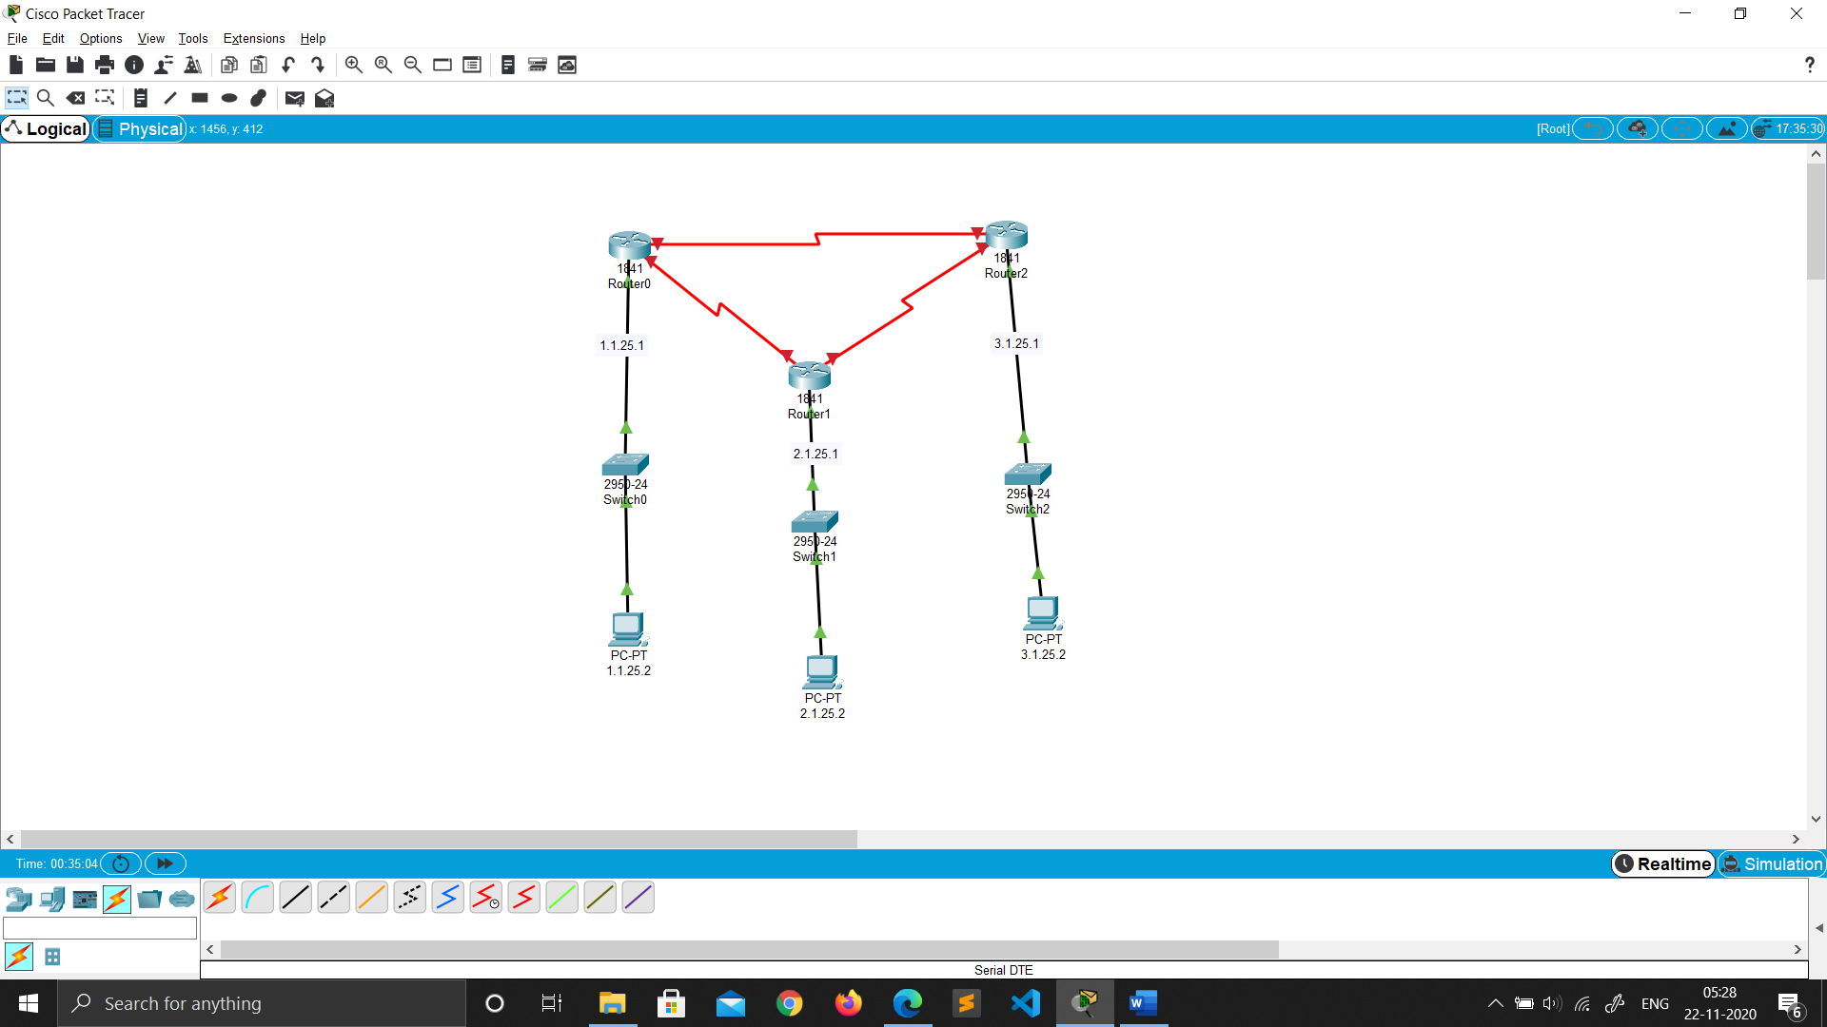

Connecting Router’s

1. Click on the router.

2. Go to Config.

3. Then config the serial ports as required.

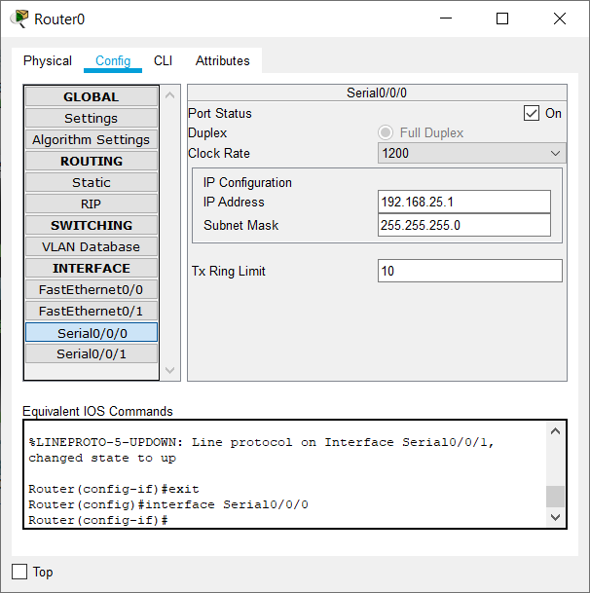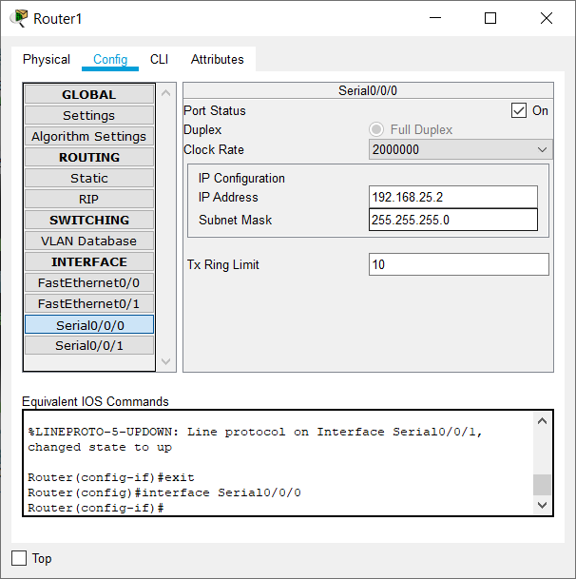

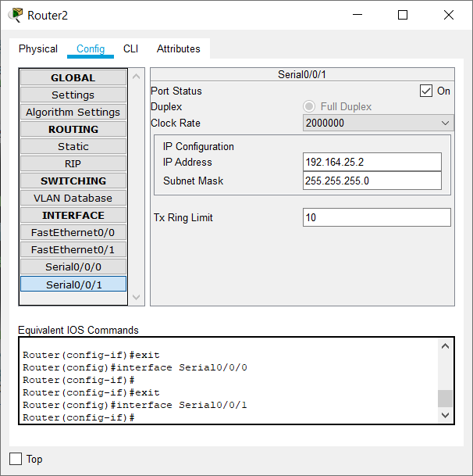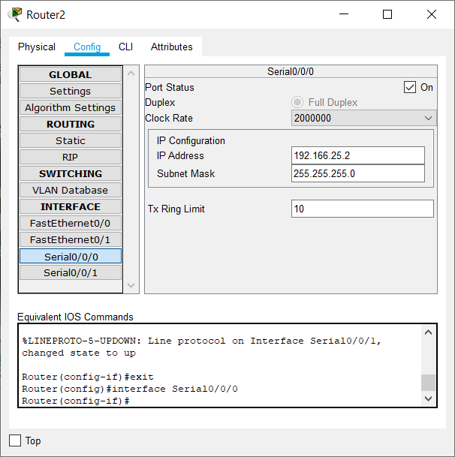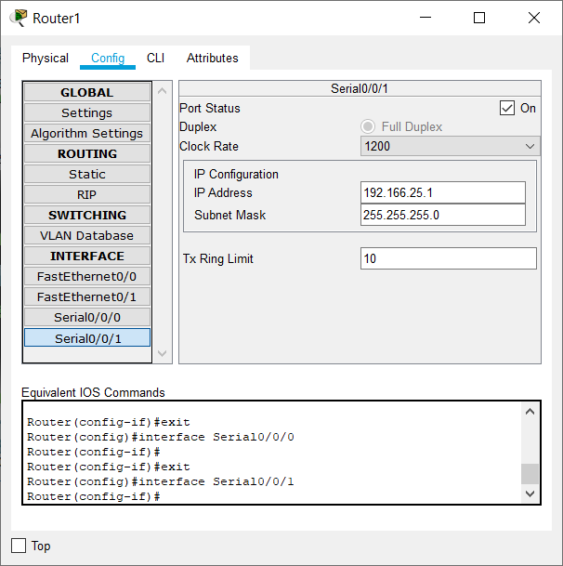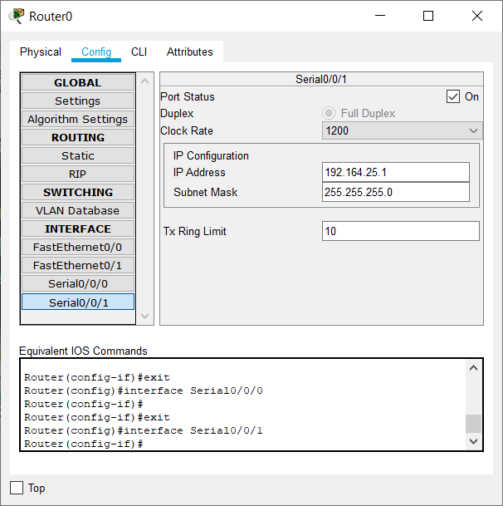

Configuring OSPF

Adding networks to communicate between (for each router)

1. Click on the router.
2. Go to CLI.
3. Type “exit” and hit ENTER to enter the config mode.
4. Then type “router ospf 1” to configure OSPF protocol for this router
5. Then type “network <the immediate network id> <compliment of its subnet mask> area 0”.
6. Repeat step 5 to add all the neighbour networks.
7. Then type “exit”.
8. Go to CONFIG -> settings and select SAVE.
9. 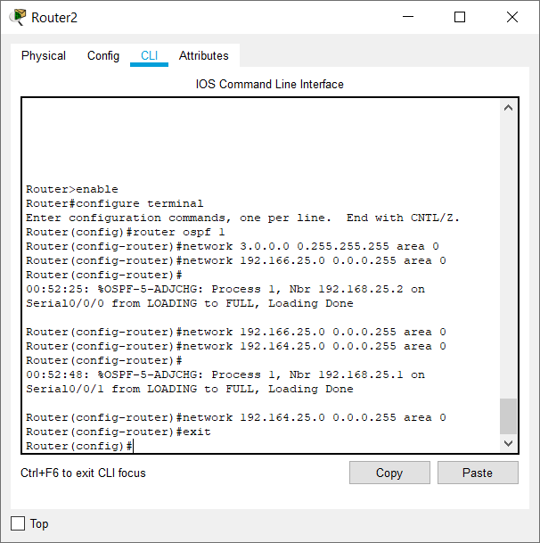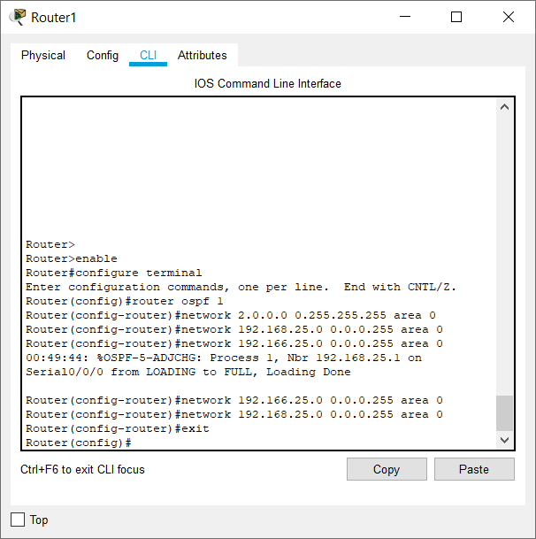Repeat the abbove steps for all routers. 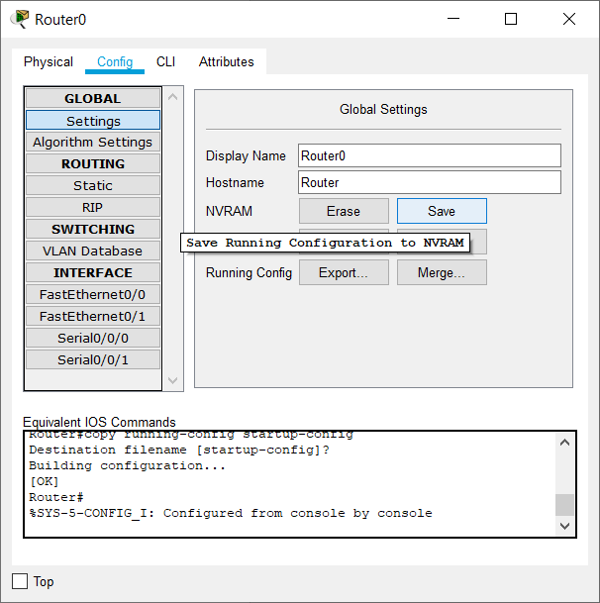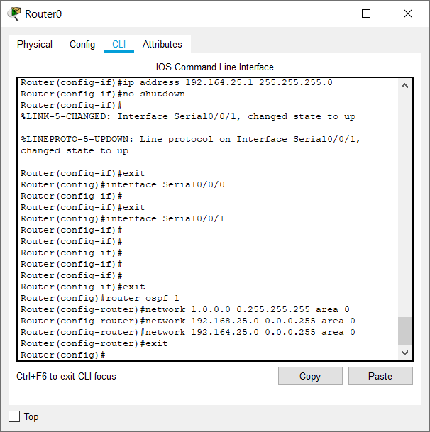

Real Mode Simulation (OSPF)

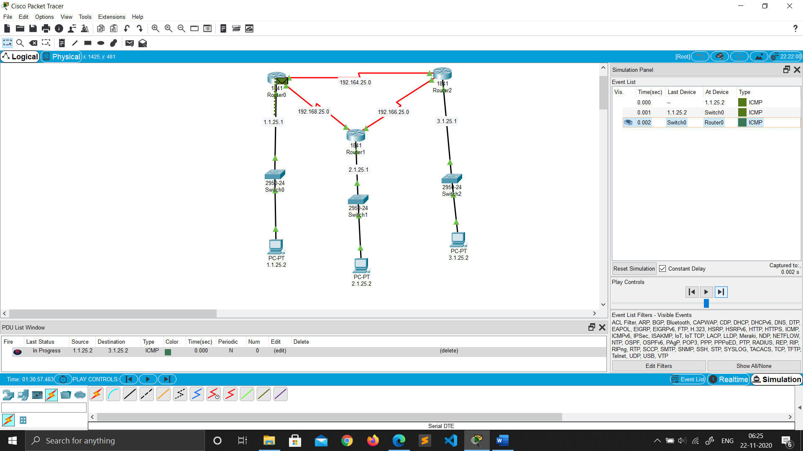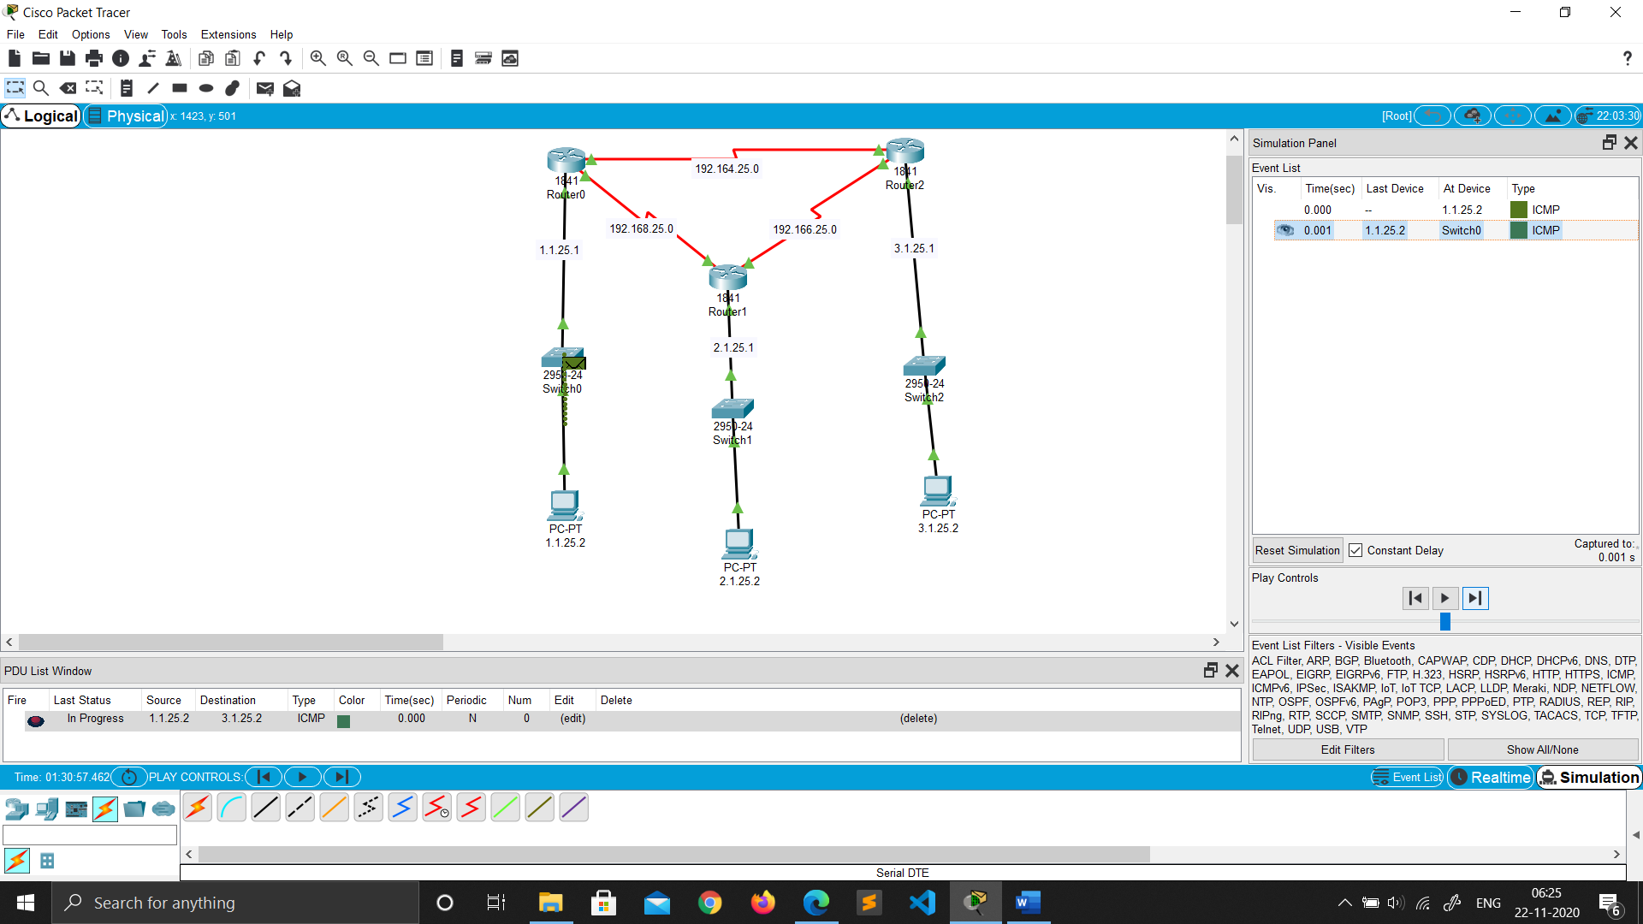

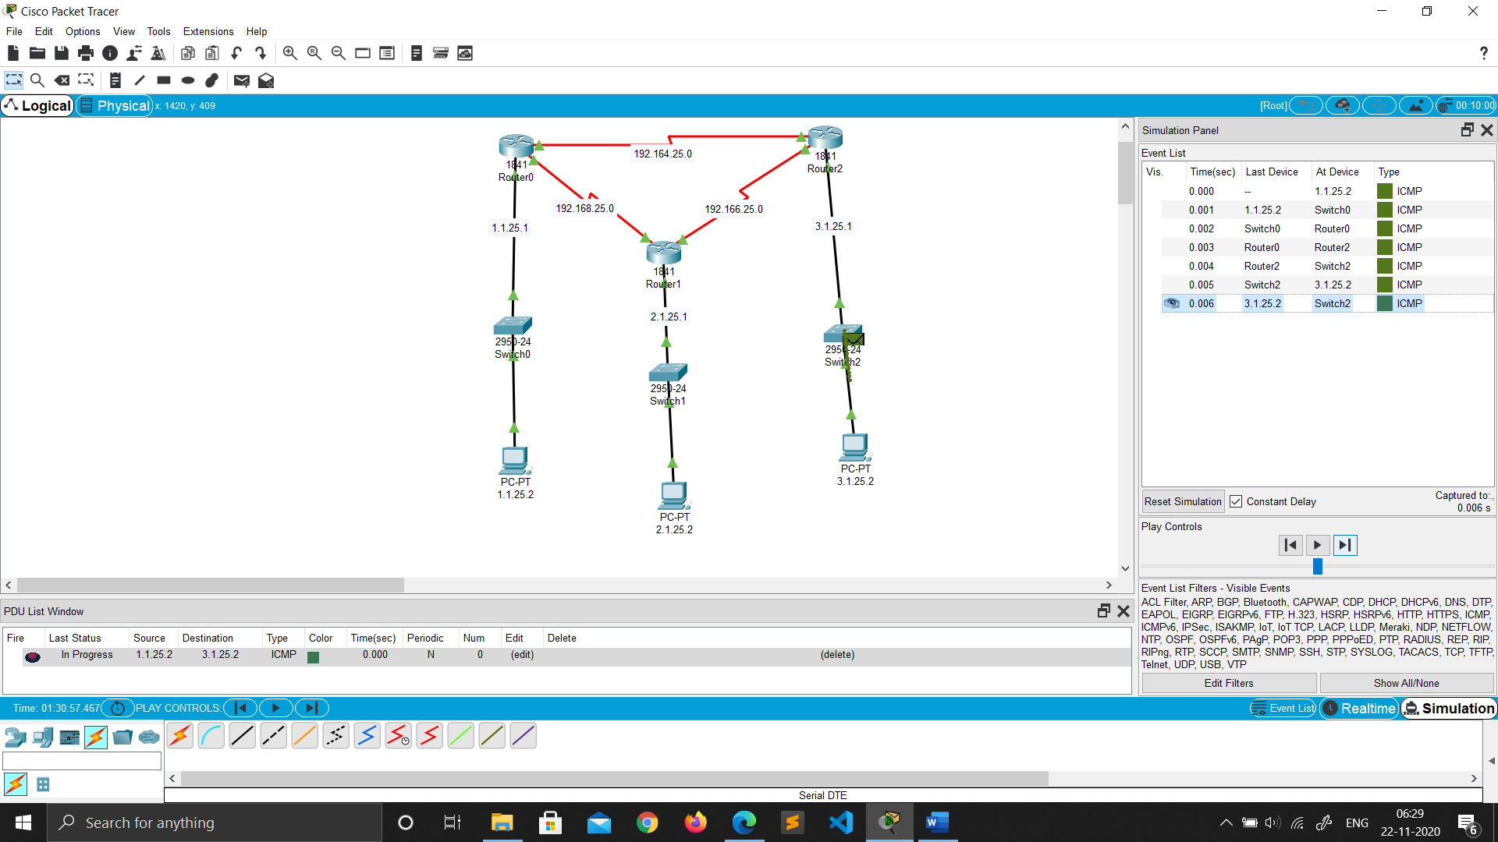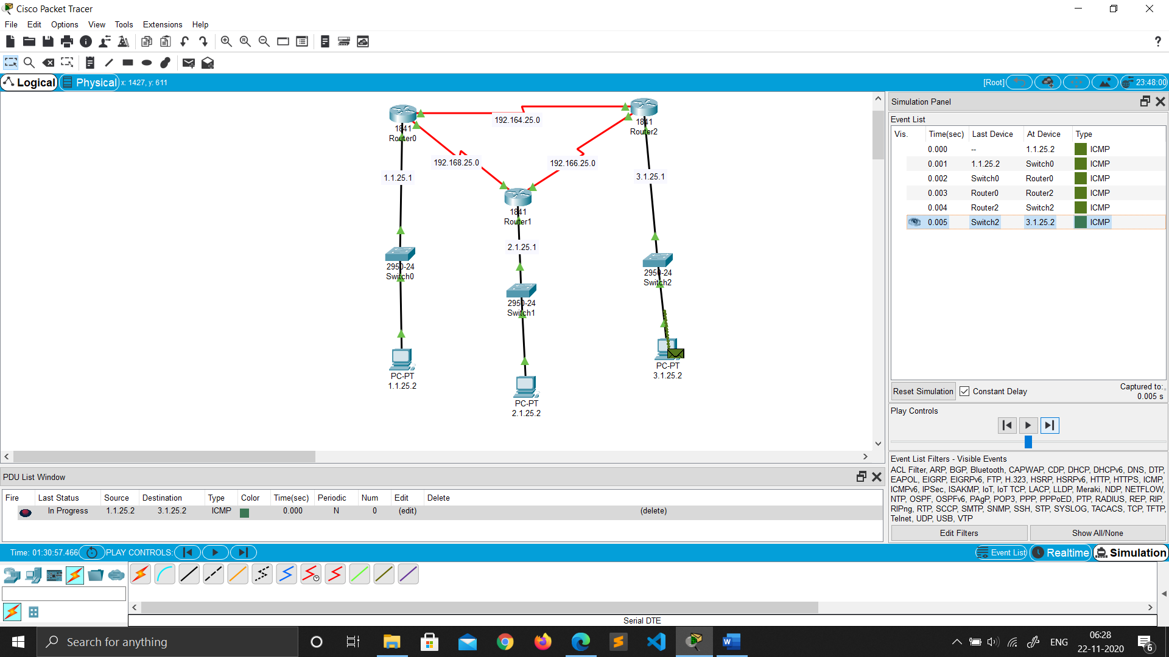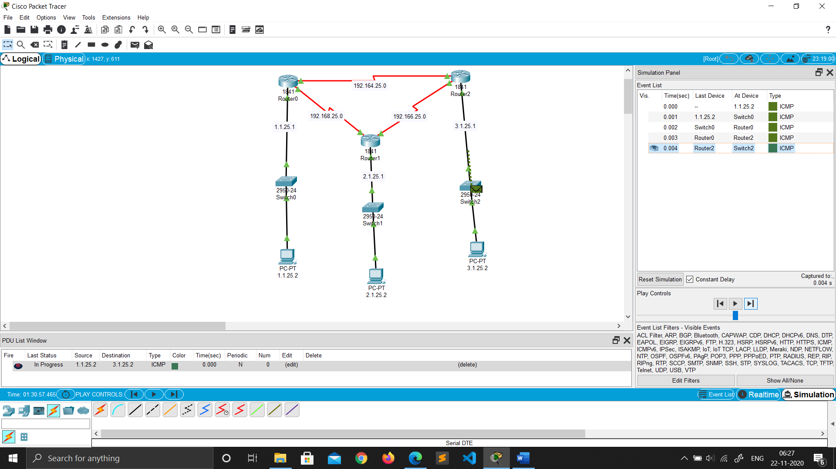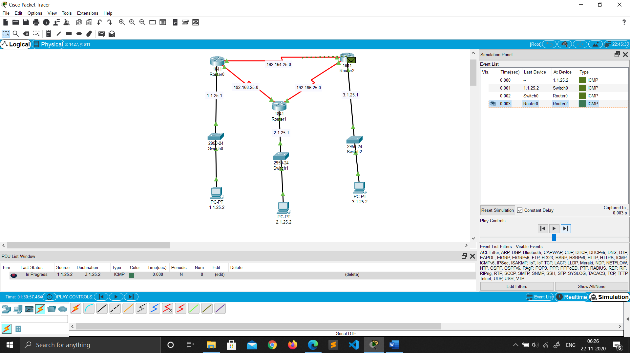

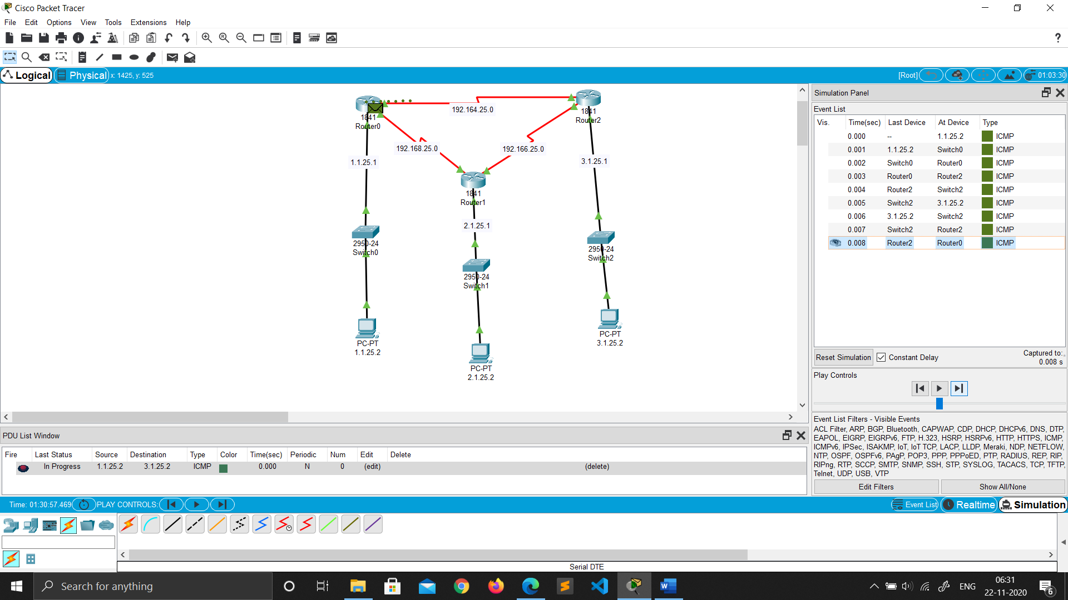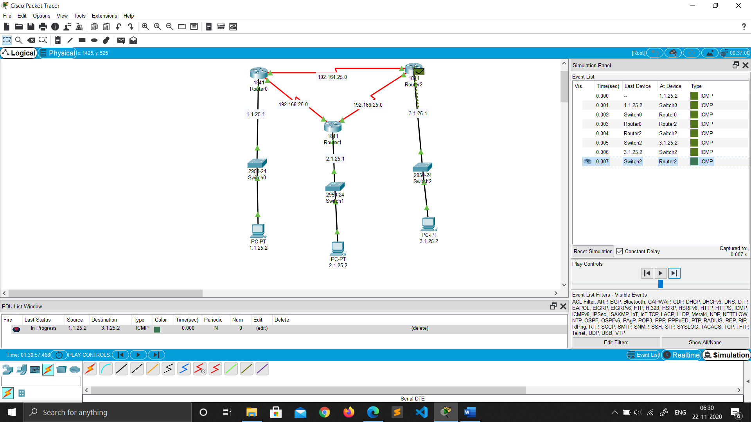

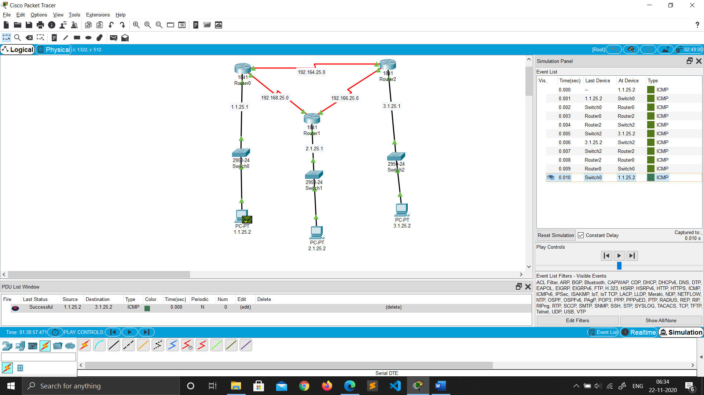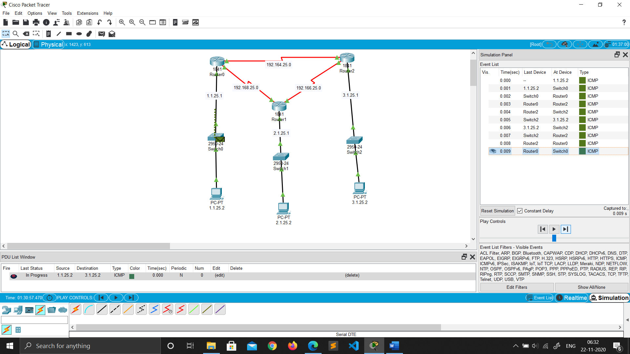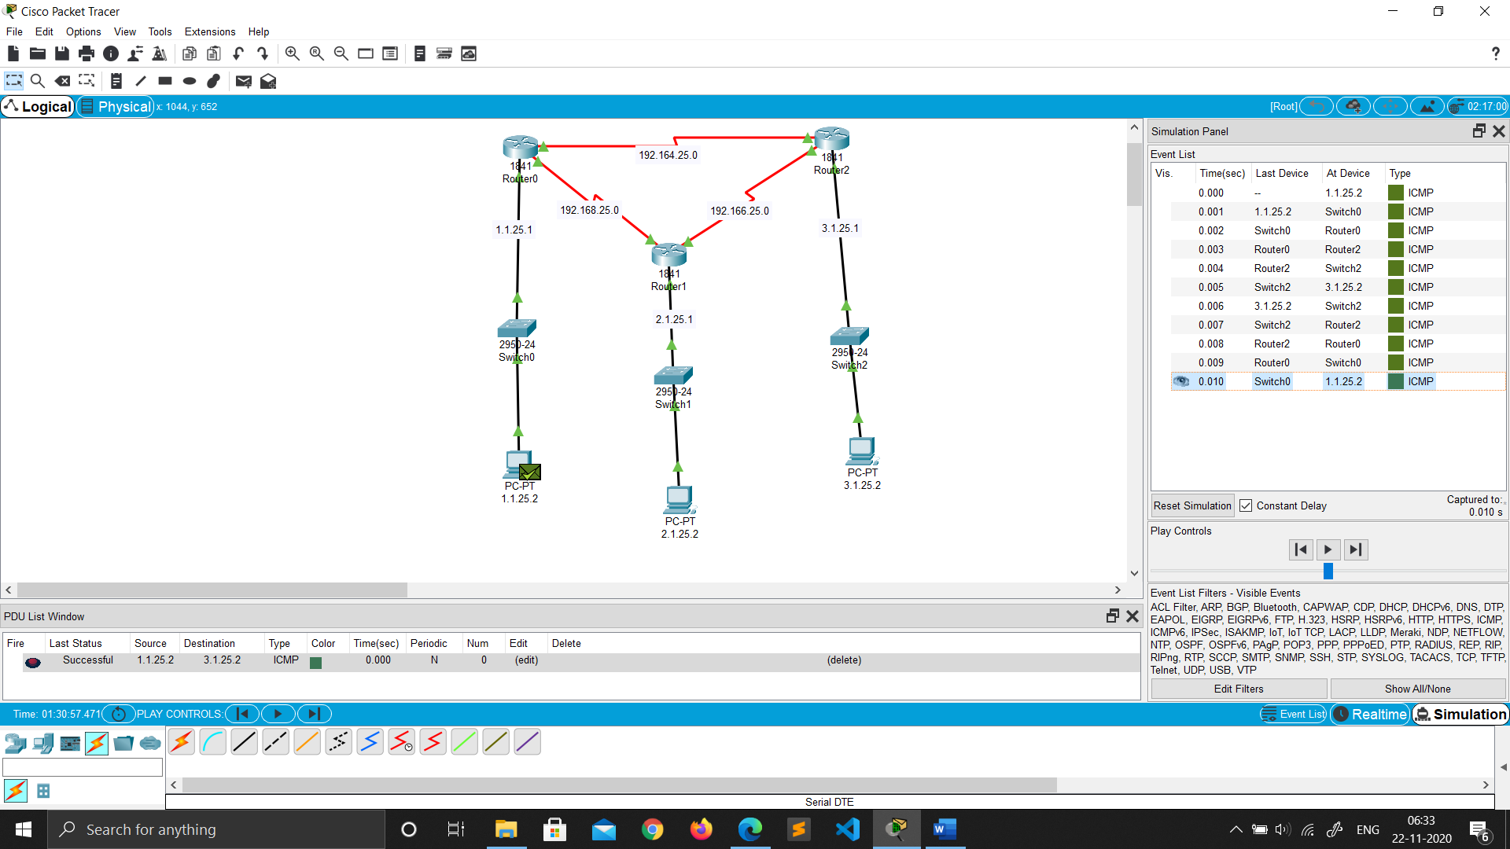

* **BGP(Broder Gateway Protocol) PROTOCOL**

Network Topology (BGP)

1. Drag and drop PC from End Devices.
2. Drag and drop switch(2950-24) for each network and router(1841) for each network.
3. Connect the PC and switch using Copper straight through cable in fast ethernet ports of both PC and switch.
4. Repeat Step 3 to connect switch to router.



1. As by default not many ports are available on routers, we need to add some extra serial ports to form the network.
2. To add the serial ports click on the router go to PHYSICAL ----> WIC-2T.
3. Turn off the router by toggling(click) the switch.(FOR ALL ROUTERS)



1. Now Drag and drop the ports image from bottom just to the left of switch.

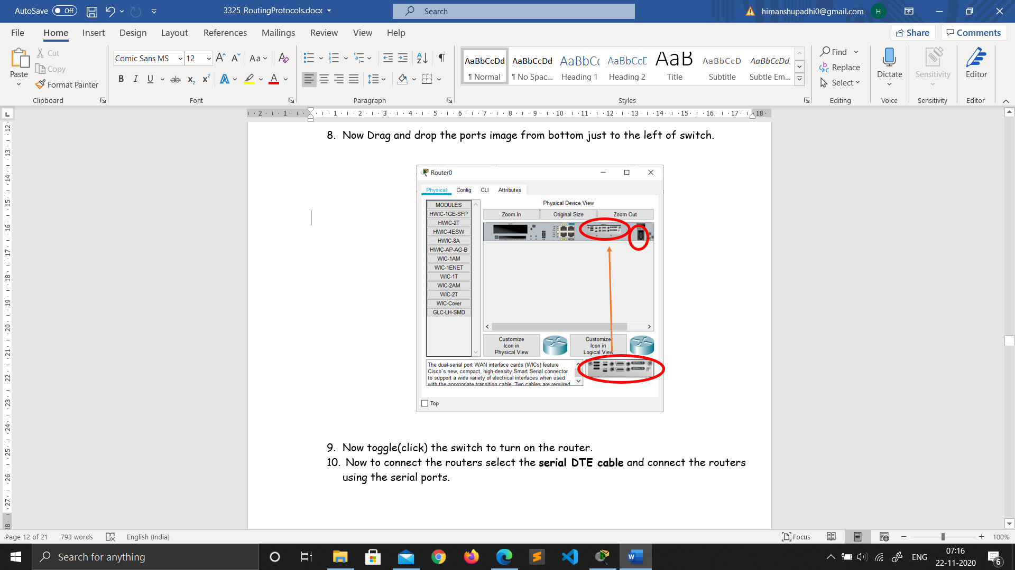

1. Now toggle(click) the switch to turn on the router.
2. Now to connect the routers select the **serial DTE cable** and connect the routers using the serial ports.

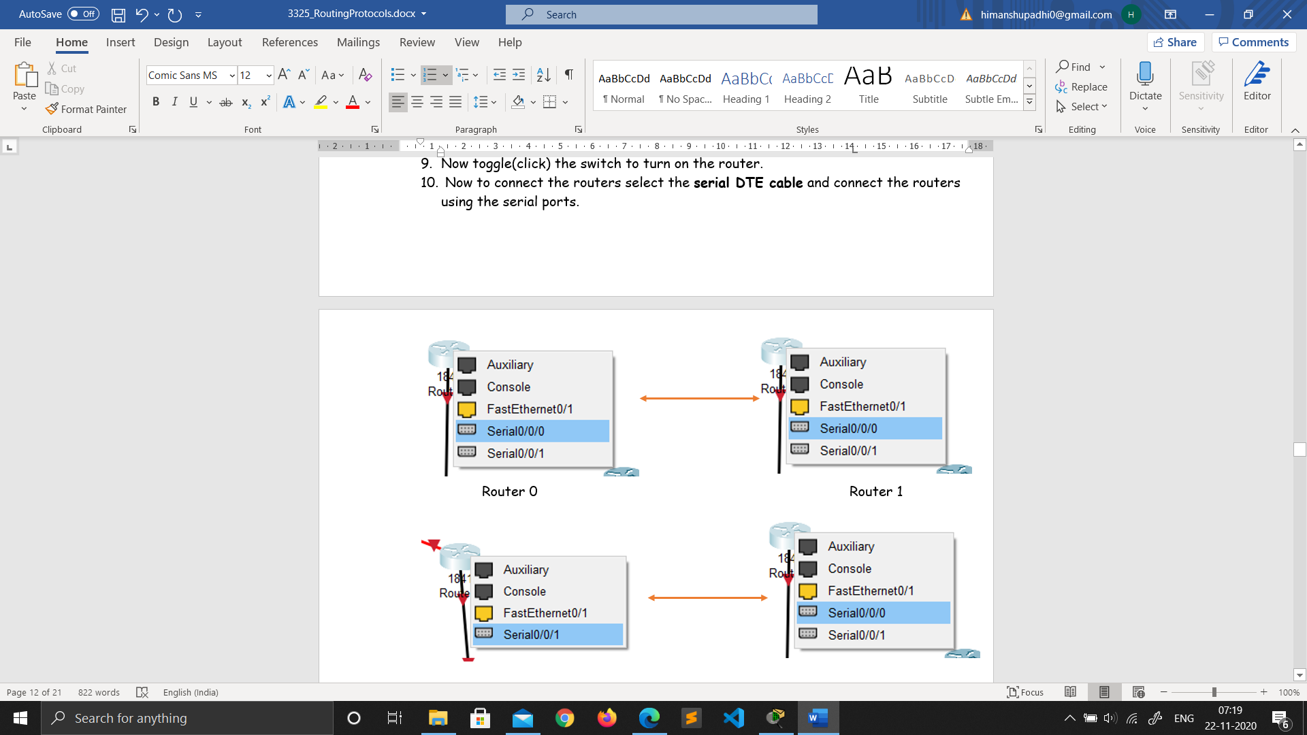

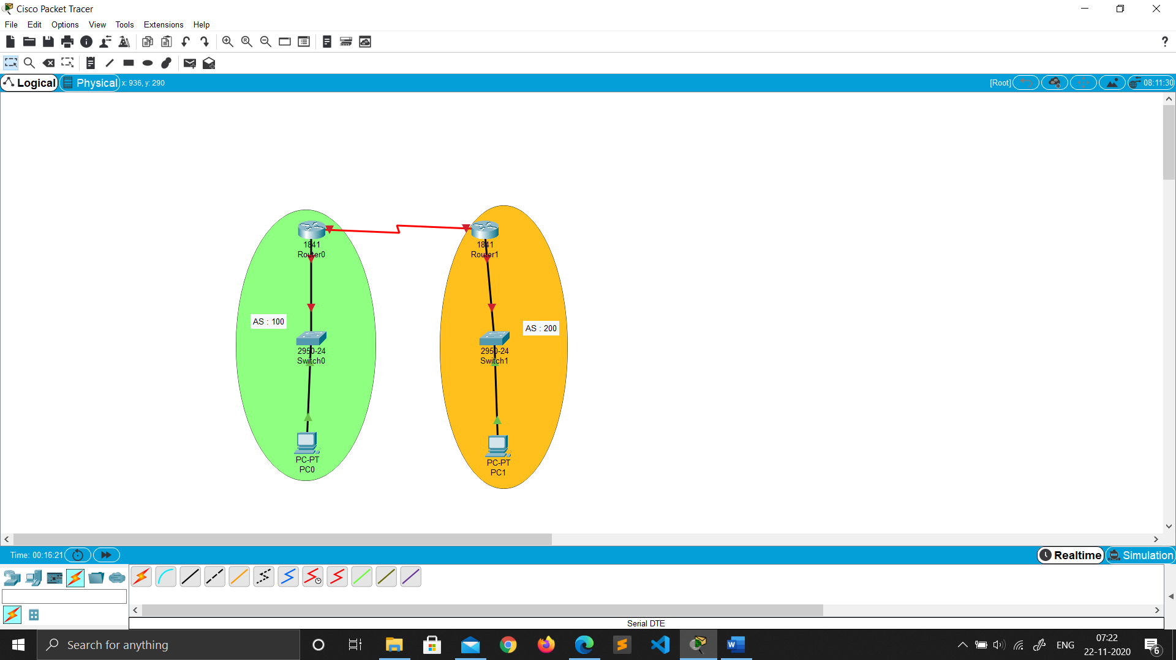

**Network**

Ip Address Configuration (BGP)

ADDING gateway in router

1. Click on the router.

2. Go to Config ->Fast ethernet 0/0.

3. Then add the gateway for each network in all the routers.

4. Then turn on the port.



Assigning IP address to the PC’s

1. Click on the PC.

2. Go to Desktop ->IP configuration.

3. Add the Ip address and the gateway.



Connecting Router’s

1. Click on the router.

2. Go to Config.

3. Then config the serial ports as required.



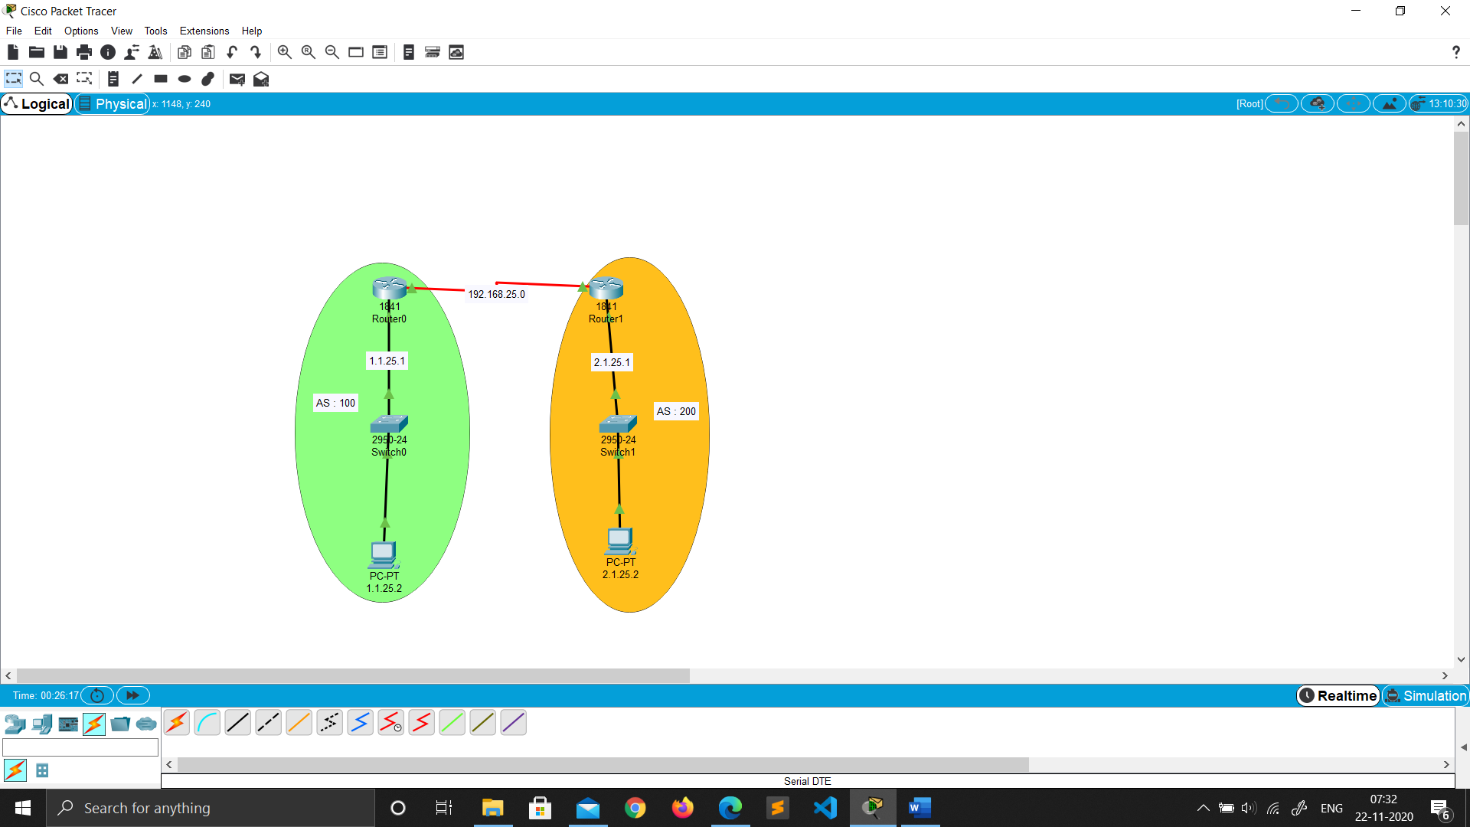

Configuring BGP

For Router0 :

1. Click on the router.
2. Go to CLI.
3. Type “exit” and hit ENTER to enter the config mode.
4. Then type “router bgp 100” .
5. Then type “network 192.168.25.0“.
6. Then type “network 1.0.0.0“.
7. Then type “neighbor 192.168.25.2 remote-as 200”.
8. Then type “neighbor 2.1.25.2 remote-as 200”.
9. Then type “exit”.
10. Go to CONFIG -> settings and select SAVE.

For Router1 :

1. Click on the router.
2. Go to CLI.
3. Type “exit” and hit ENTER to enter the config mode.
4. Then type “router bgp 200” .
5. Then type “network 192.168.25.0“.
6. Then type “network 2.0.0.0“.
7. Then type “neighbor 192.168.25.1 remote-as 100”.
8. Then type “neighbor 1.1.25.2 remote-as 100”.
9. Then type “exit”.
10. Go to CONFIG -> settings and select SAVE.

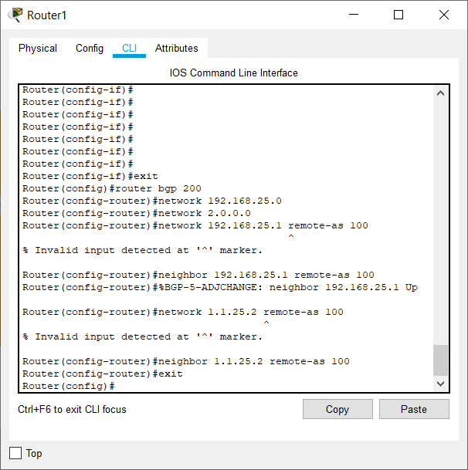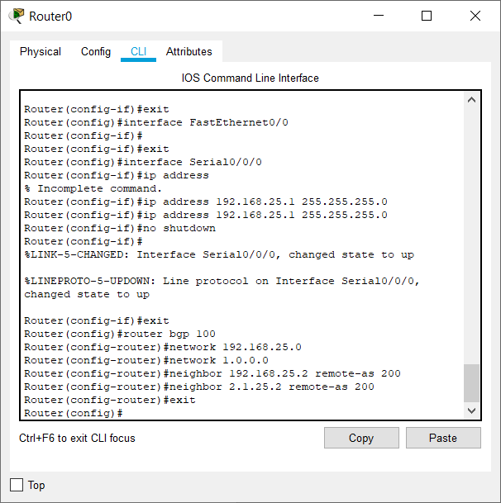

Real Mode Simulation (BGP)

